Department Computer Science and Engineering
Cyber Security Lab manual for reference

Introduction
The Cyber Security Laboratory is designed to provide hands-on experience in understanding, analyzing, and mitigating security threats. The lab exercises are aimed at bridging the gap between theoretical knowledge and practical skills essential for the modern cybersecurity professional. By working on real-world scenarios—ranging from network packet analysis to exploitation of vulnerabilities and forensic investigations—students gain a deep understanding of cyberattack methodologies and corresponding defense mechanisms.
This laboratory makes extensive use of industry-relevant tools such as Wireshark, Burp Suite, DVWA, GCC and specialized forensic utilities. Through these tools, learners are exposed to concepts such as network monitoring, vulnerability exploitation, malware analysis, injection attacks, and buffer overflow exploitation, along with defensive strategies.

Objectives
- To develop proficiency in identifying and analyzing cyber threats through practical exercises.
- To demonstrate techniques for exploiting and securing vulnerable systems.
- To familiarize students with common cybersecurity tools and their applications.
- To understand the principles of secure coding, threat mitigation, and data protection.
- To introduce basic forensic analysis techniques for evidence collection and investigation.

Description of Lab Programs
- Packet Filtering and Analysis using Wireshark/Burp Suite This program focuses on monitoring and analyzing network traffic to detect anomalies and threats. Students learn how to apply filters, inspect packet contents, and identify suspicious communication patterns.

SQL Injection Attack
Students simulate SQL Injection attacks on vulnerable web applications to understand how improper input validation can lead to database exploitation. They also study mitigation techniques such as prepared statements and input sanitization.

Command Injection Attack
This program demonstrates how improperly validated user inputs can allow attackers to execute arbitrary commands on the host system. Tools like DVWA and Burp Suite are used to exploit and secure the application.

Buffer Overflow Illustration
Using GCC, GDB, and Linux debugging tools, students explore the concept of buffer overflows—how memory corruption occurs, how attackers exploit it, and the defensive programming practices to prevent such vulnerabilities.

File Comparison for Forensic Investigation (Compare It Tool)
This exercise involves comparing two files for forensic analysis, identifying modifications, and validating evidence integrity using tools designed for binary/text file comparison.

Key Features
  - Hands-on Practice: Real-world attack and defense simulations in a controlled environment.
  - Industry Tools: Usage of widely recognized tools such as Wireshark, Burp Suite, DVWA, GCC, and forensic utilities.
  - Safe Learning Environment: Execution of potentially harmful attacks in sandboxed virtual labs.
  - Practical Relevance: Scenarios aligned with current cyber threat landscapes.
  - Skill Development: Emphasis on analysis, critical thinking, and secure programming practices.

Technology Used
  - Wireshark: Network packet capture and analysis.
  - Burp Suite: Web vulnerability scanning and exploitation.
  - DVWA (Damn Vulnerable Web Application): Learning platform for injection and exploitation testing.
  - GCC : Compilation and debugging of C programs for buffer overflow analysis.
  - Compare It Tool: File comparison for digital forensics.
  - Linux Environment (Kali Linux): Primary platform for execution of lab exercises.
  - Virtualization Tools: VirtualBox/VMware for creating isolated testing environments.

Installation Setup
- Download Oracle VirtualBox for Windows and complete the installation.
- Download kali linux ( https://www.kali.org/get-kali/#kali-platforms )(running inside VirtualBox)
- Click on Virtual Machines
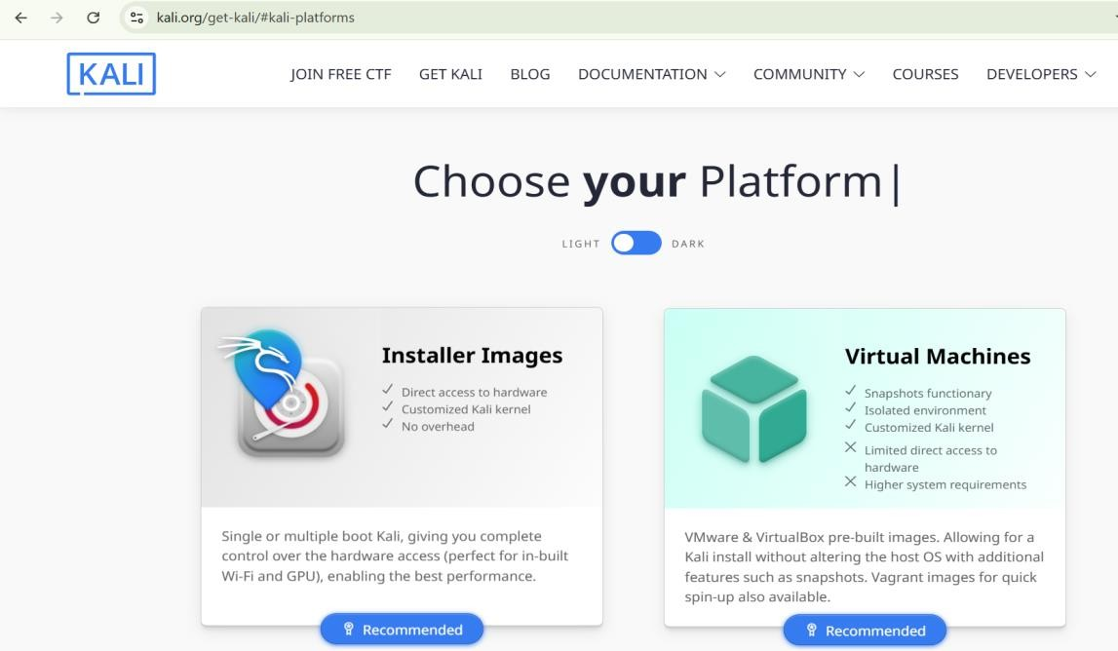

Kali Linux (running inside Virtual Box)
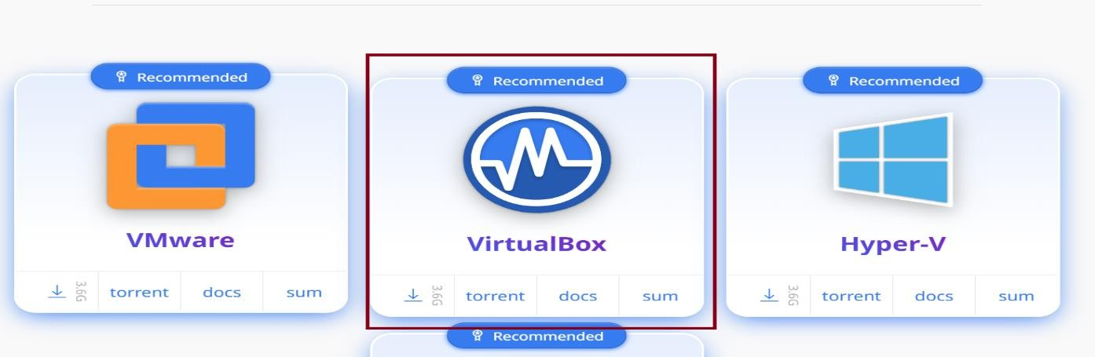

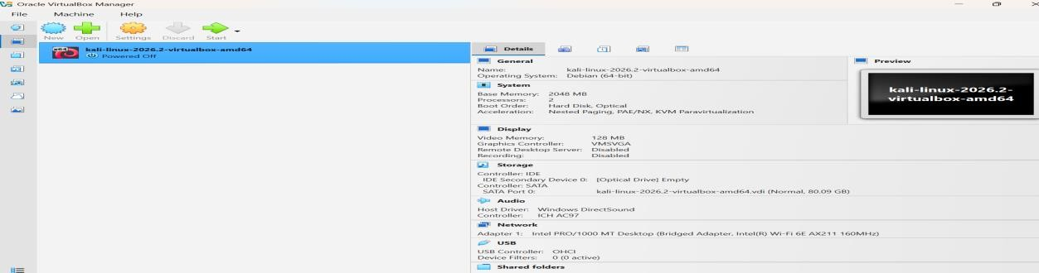
After downloading, extract the file and open it using Oracle VirtualBox, as shown in th image below.

Packet Filtering and Analysis using Wireshark/Burp Suite

Aim
To capture, filter, and analyze network packets using Wireshark on Kali Linux in VirtualBox.

This experiment helps students understand how data travels across a network and how cyber professionals monitor network traffic using Wireshark and Burp Suite. Students learn to analyze packets, identify network protocols, and understand the importance of secure communication. A real-world example is capturing login credentials sent over an unsecured HTTP connection, demonstrating how attackers can steal sensitive information. The experiment emphasizes the need for HTTPS, encryption, and secure network practices used in modern organizations.

Procedure

Configure VirtualBox Network for Packet Capture
    - Open VirtualBox → Kali VM → machine→Settings → Network.
    - Set Adapter 1:
      - Attached to: Bridged Adapter
      - Promiscuous Mode: Allow All
      - Cable Connected: ✔◻
    - Save settings.

Start Kali Linux VM
    - Boot the Kali Linux VM in VirtualBox.
  - Run Wireshark as Root (Application→Wireshark)
sudo wireshark
  - Select the network interface (eth0)

Start Packet Capture
    - Click on eth0 to begin capturing packets.
    - Generate network traffic (open websites, ping servers, or run curl commands).

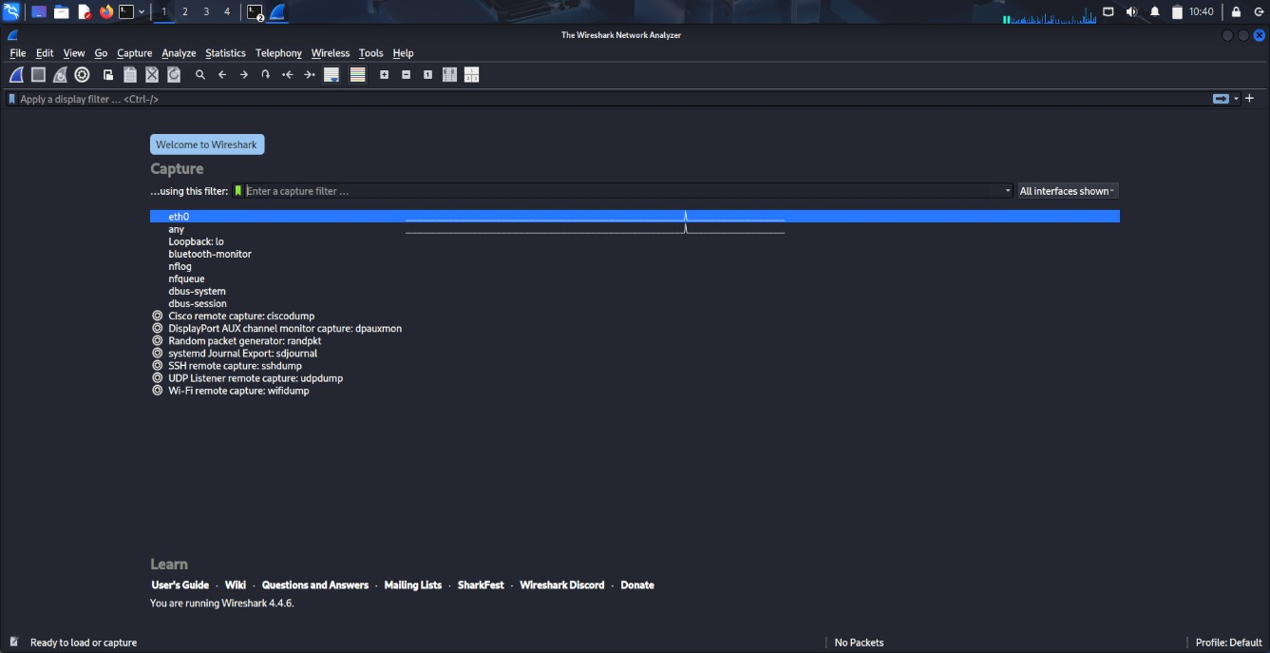
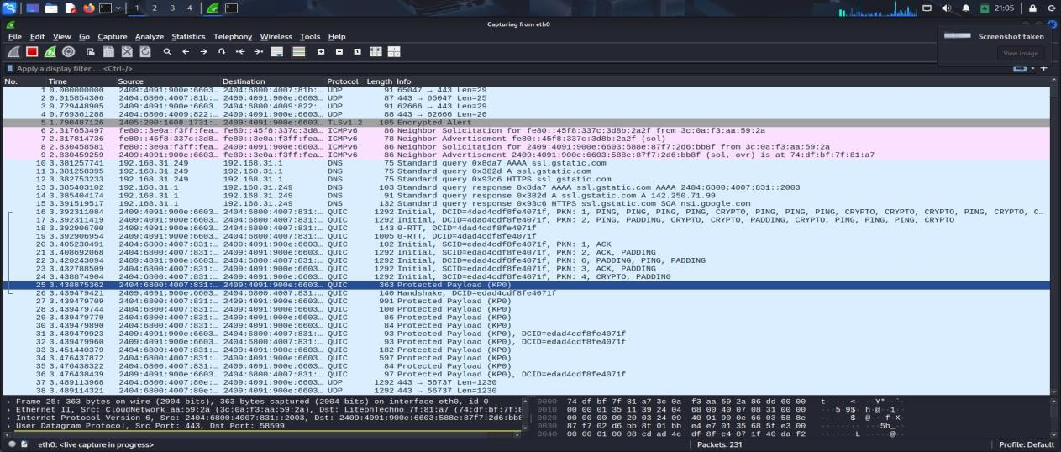

Apply Display Filters for Analysis
Examples:

DNS Packets:
dns

HTTPS Packets:
tls

Packets from specific IP:
ip.addr == 18.161.216.37

TCP Port 443:
tcp.port == 443

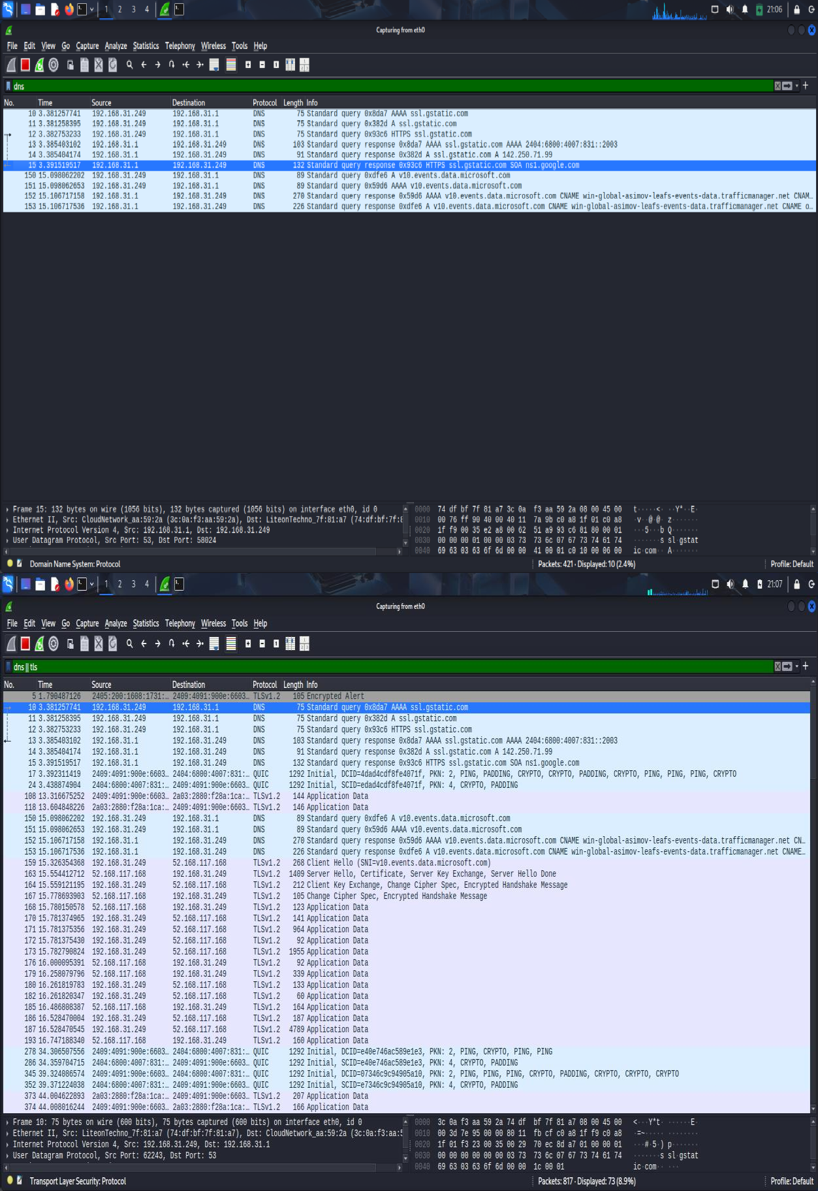

Analyze Captured Packets
    - Select any packet and expand:
      - Ethernet Layer: Source & Destination MAC addresses
      - IP Layer: Source & Destination IP addresses
      - TCP/UDP Layer: Port numbers, flags (SYN, ACK)
      - Application Layer: Protocol details (DNS query, HTTP request, TLS handshake)

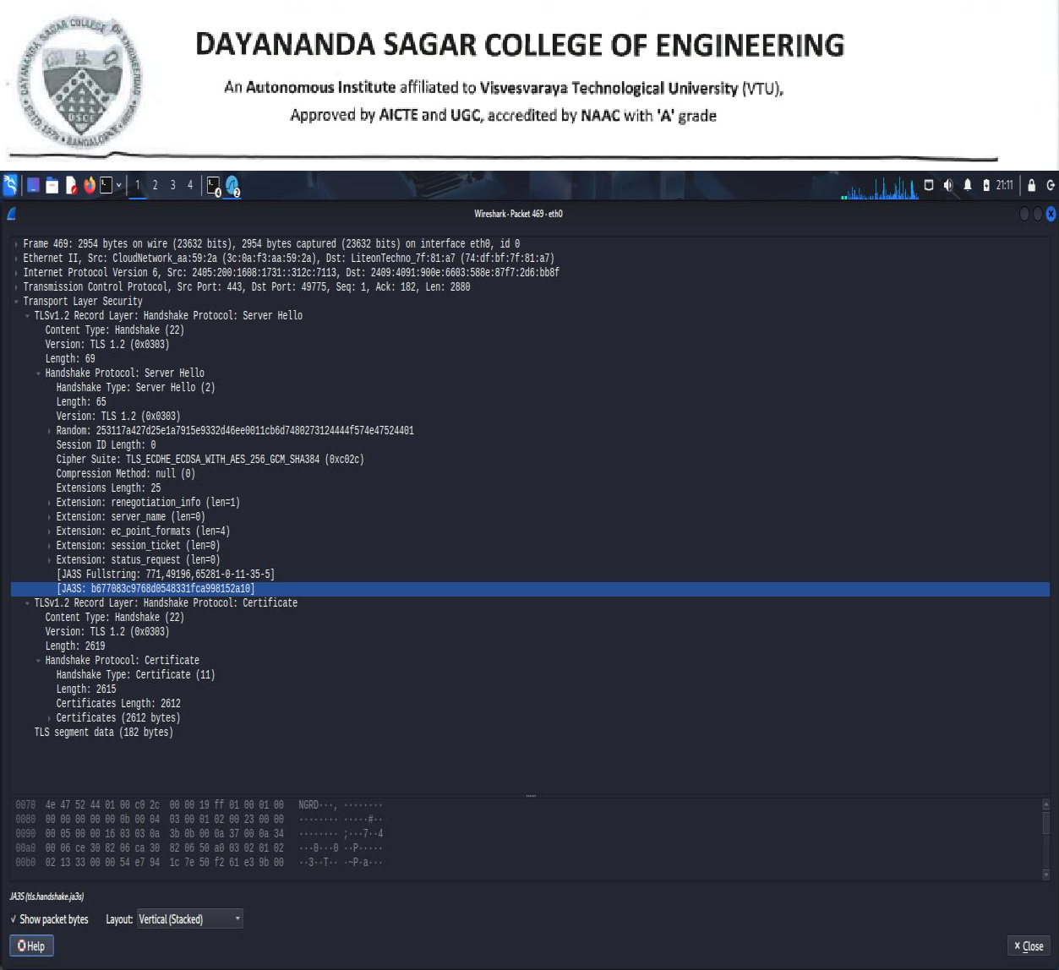
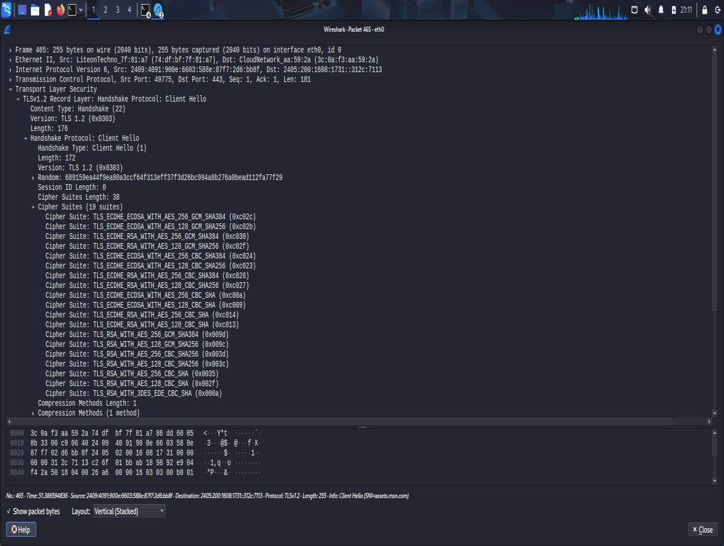

Stop Capture and Save

Stop the packet capture by clicking the red square button.

Save capture file in .pcap format for submission.

Part B: Capturing Login Credentials over HTTP
Start the Virtual Machine (VM).
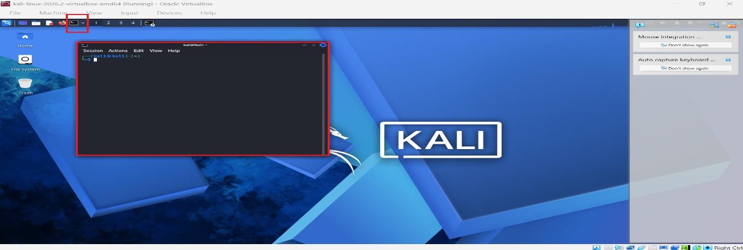
open Terminal

Step 1 – Setup Apache Web Server
sudo service apache2 start
sudo mkdir -p /var/www/html/testlogin cd /var/www/html/testlogin

Step 2 – Create Login HTML Page
sudo nano login.html

html CopyEdit
<!DOCTYPE html>
<html>
<head>
<title>Test Login Page</title>
</head>
<body>
<h2>Login Form</h2>
<form action="login.php" method="post">
Username: <input type="text" name="username"><br><br> Password: <input type="password" name="password"><br><br>
<input type="submit" value="Login">
</form>
</body>
</html>
Save (Ctrl + O → Enter → Ctrl + X).

Step 3 – Create PHP Script
sudo nano login.php
php CopyEdit
<?php
$username = $_POST['username'];

$password = $_POST['password'];

echo "<h2>Login Attempt</h2>";
echo "Username: " . $username . "<br>"; echo "Password: " . $password . "<br>";
?>

Step 4 – Start/Enable Apache
sudo service apache2 status sudo service apache2 start

Step 5 – Test Page
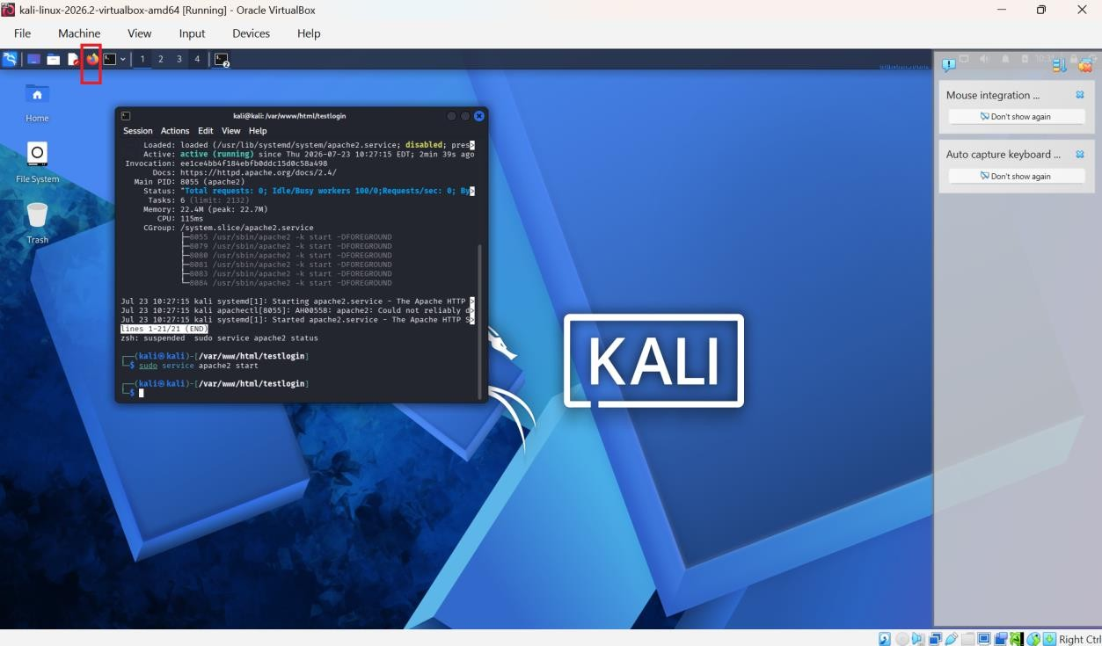
Open Firefox and browse to:http://127.0.0.1/testlogin/login.html
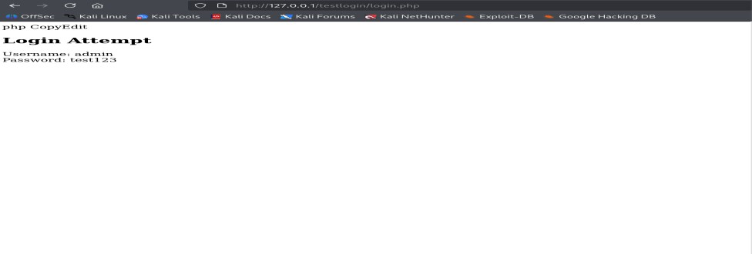
Or: Type in bash
curl http://127.0.0.1/testlogin/login.html

Step 6 – Capture with Wireshark
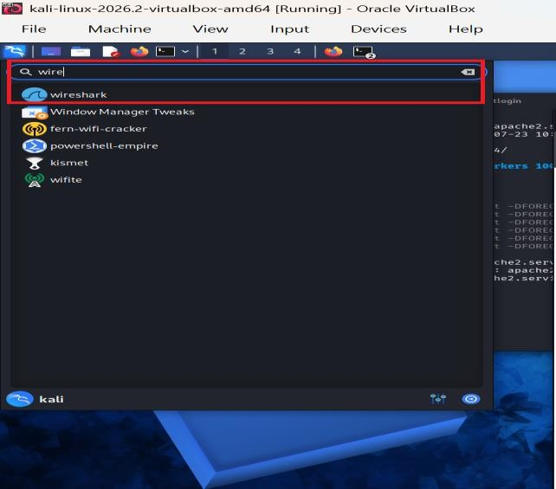
Open Wireshark and select the loopback (lo) interface.
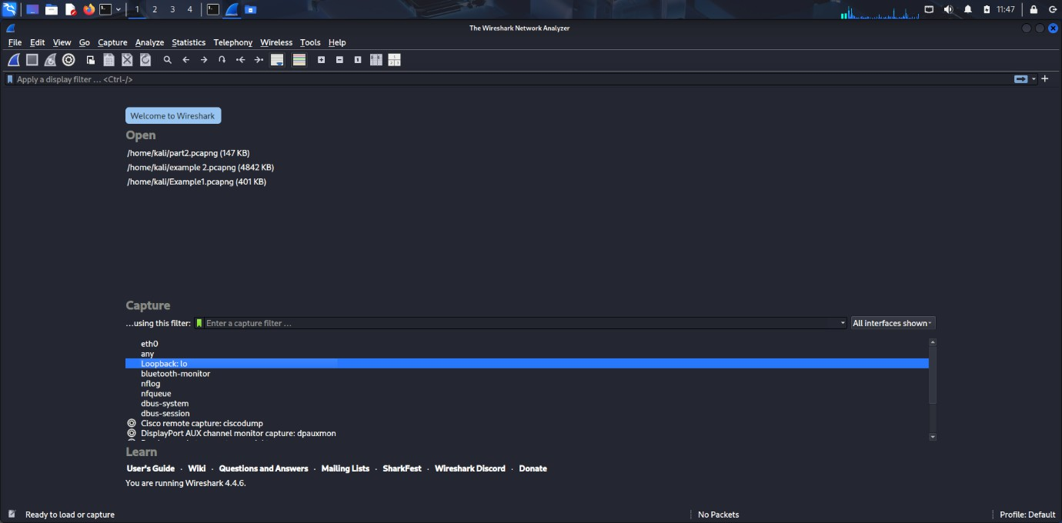
- Start capture.

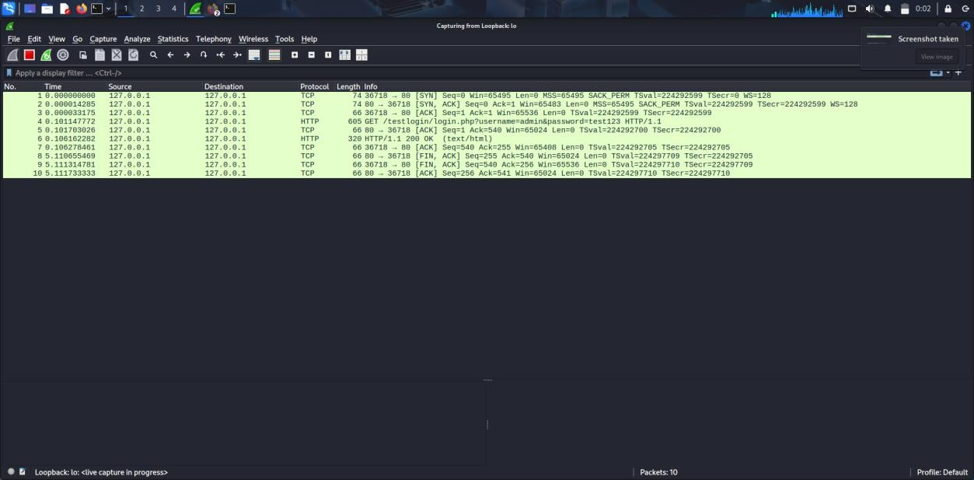
- Apply filter:
http.request.method == "POST"
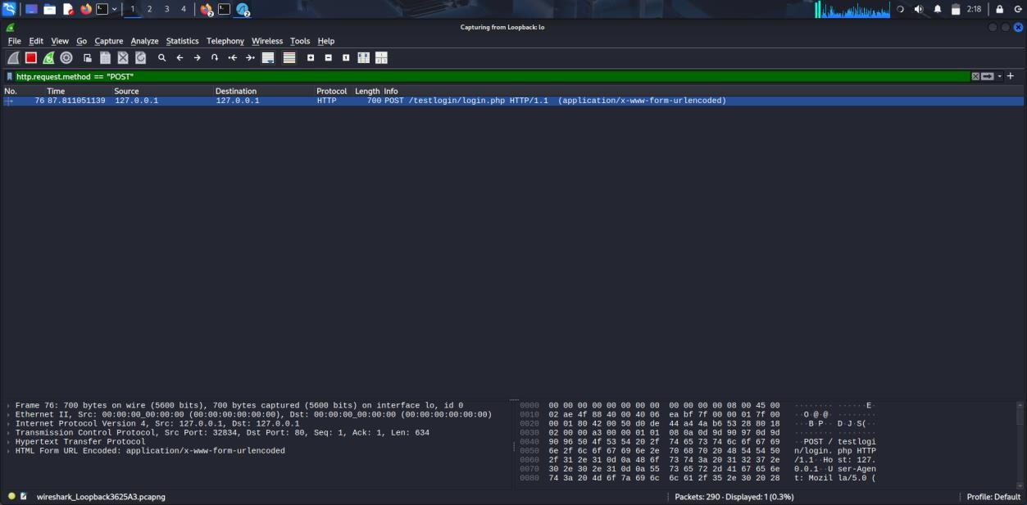
Step 7 – Perform the Login Attempt (Firefox)
- Username: admin
- Password: test123

Click the Login button.

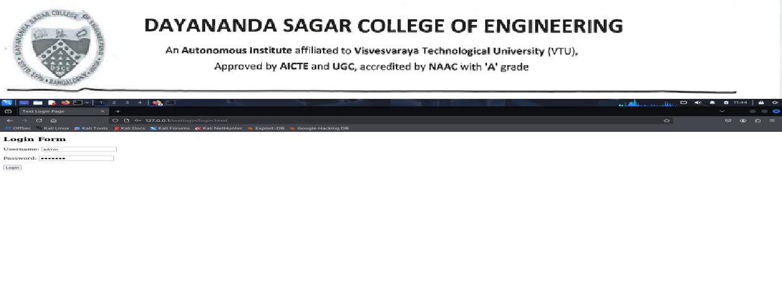

Step 8 – Analyze Packets
- Locate POST packet.
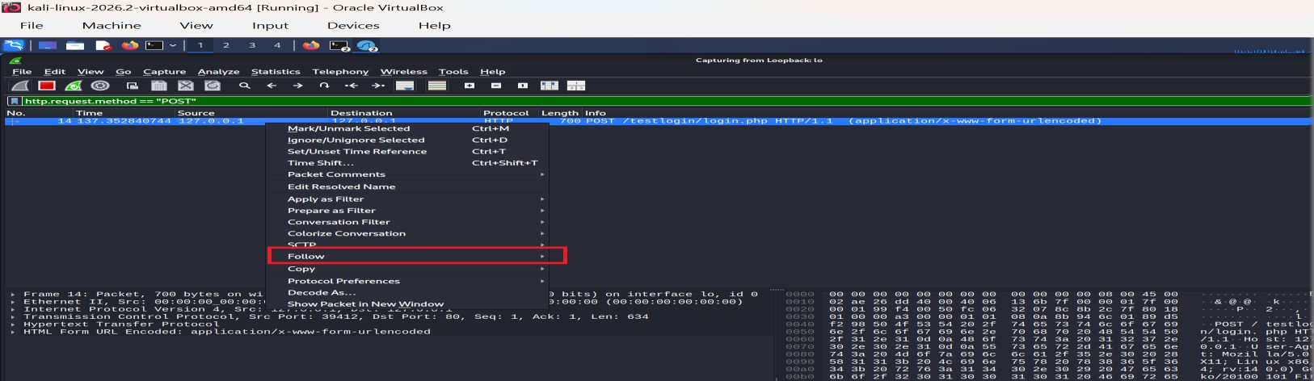
- Right-click → Follow → TCP Stream.

Credentials will be visible in plain text.
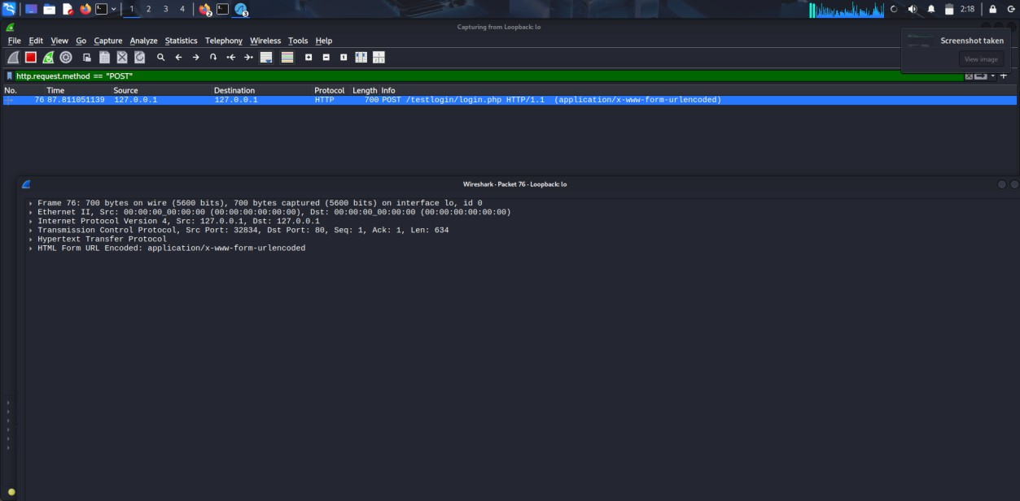

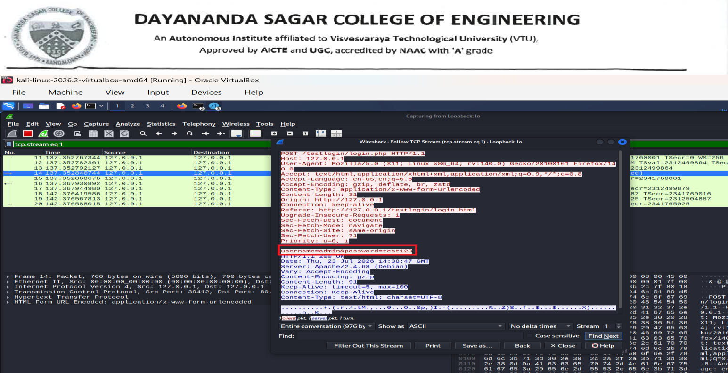

Finally, power off the virtual machine

Close the VirtualBox window

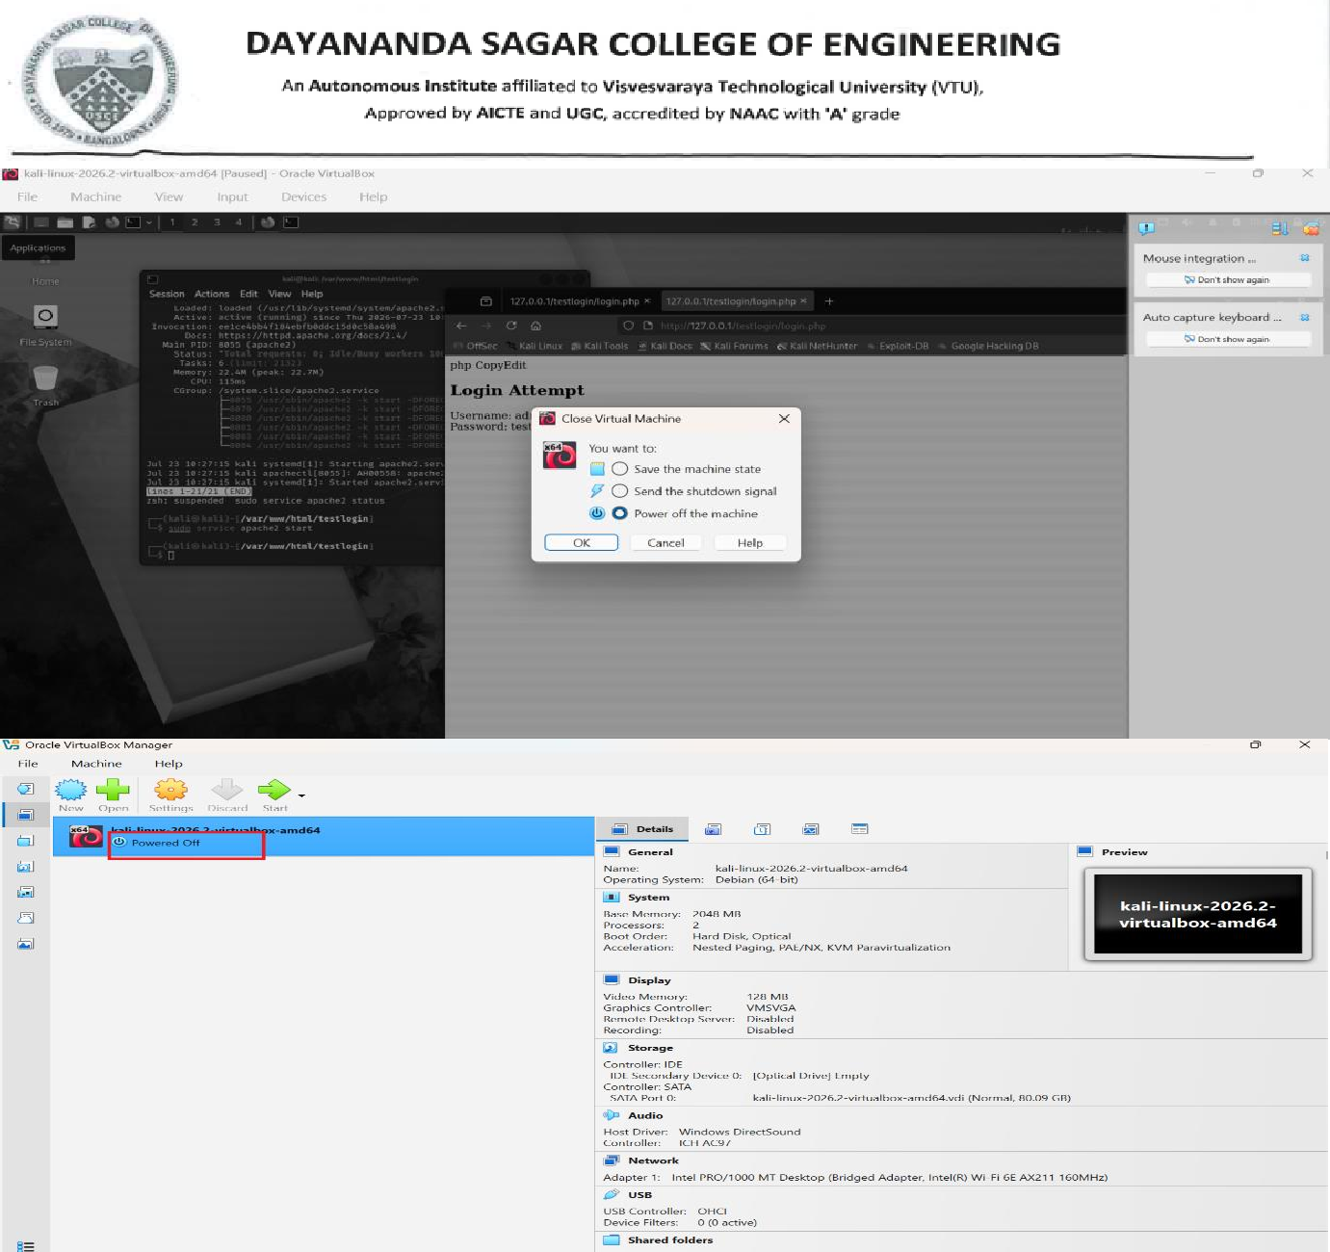

Observations
- Network traffic from various applications can be captured in real-time.
- Protocol filters help narrow down the traffic of interest.
- Details such as source/destination IP, MAC addresses, ports, and application data can be examined.
- HTTP POST requests transmit data in plaintext.
- Credentials can be directly read in the captured packets when using HTTP.

Using HTTPS would encrypt this data and prevent such interception.

- To demonstrate SQL Injection vulnerabilities using DVWA and understand how improper input validation can expose sensitive database information.

SQL Injection vulnerabilities exist in production systems, they can affect the CIA Triad

DVWA (Damn Vulnerable Web Application) is a free, open-source web application that has been intentionally designed with security vulnerabilities. It provides a safe environment for students, developers, and security professionals to learn, practice, and understand common web application attacks without targeting real-world systems. It allows students to explore common vulnerabilities such as SQL Injection, Cross-Site Scripting (XSS), Command Injection, File Inclusion, and CSRF without affecting real systems. DVWA is widely used in cybersecurity education to help students understand how attacks work and, more importantly, how to prevent them using secure coding practices.

SQL Injection—and how insecure coding practices can expose sensitive database information. Using DVWA in a controlled environment, students learn how attackers exploit improper input validation and how secure coding techniques such as parameterized queries and input validation prevent such attacks. A real-world example is an online banking or e-commerce website where a vulnerable login page could allow an attacker to access customer records or modify database contents. This experiment equips students with practical skills in identifying vulnerabilities and developing secure students learn secure coding practices, which are essential for cybersecurity and software development professionals(clone to git hub)

Software Required
  - Oracle VirtualBox
  - Kali Linux
  - Apache2
  - MariaDB/MySQL
  - PHP
  - DVWA (Damn Vulnerable Web Application)
  - Firefox Browser

Step 1: Start the Virtual Machine
- Open Oracle VirtualBox.
- Select Kali Linux.
- Click Start.
- Login to Kali Linux.

Step 2: Open Terminal
Click the Terminal icon.

Step 3: Update the System
sudo apt update

Step 4: Install Apache
Check whether Apache is installed.

apache2 -v

If not installed:

sudo apt install apache2 -y

Start Apache:

sudo systemctl start apache2

Enable Apache:

sudo systemctl enable apache2

Verify:

sudo systemctl status apache2

You should see:

Active: active (running)

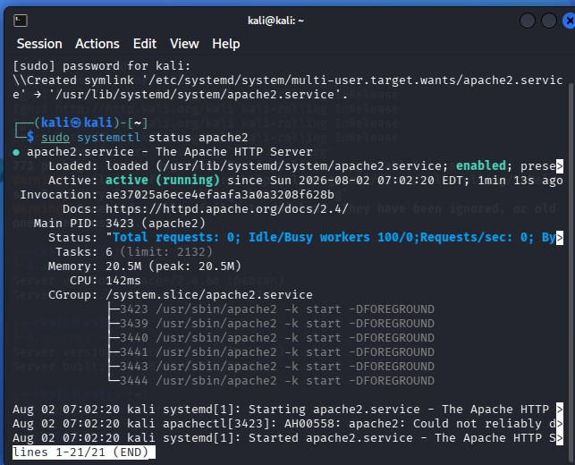

Step 5: Install MariaDB
sudo apt install mariadb-server -y

Start MariaDB:

sudo systemctl start mariadb

Enable MariaDB:

sudo systemctl enable mariadb

Verify:

sudo systemctl status mariadb

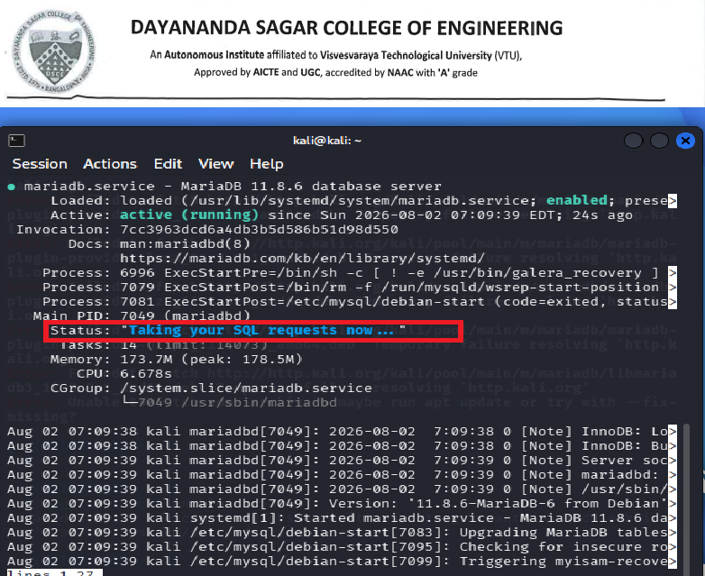

Step 6: Install PHP
sudo apt install php php-mysql libapache2-mod-php -y

Check PHP version:

php v
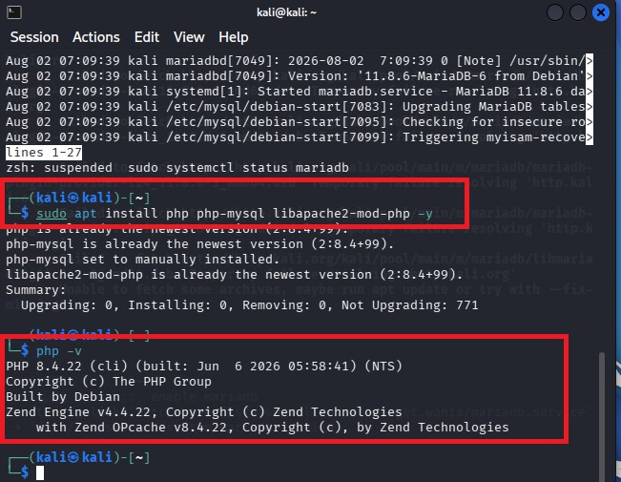

Step 7: Install Git
sudo apt install git -y
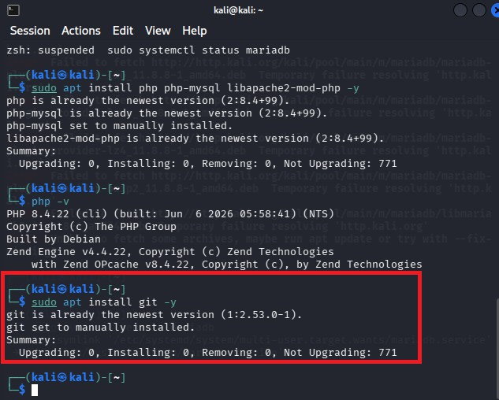

Step 8: Download DVWA
Move to the web server directory: cd /var/www/html
Remove the default page (optional): sudo rm index.html

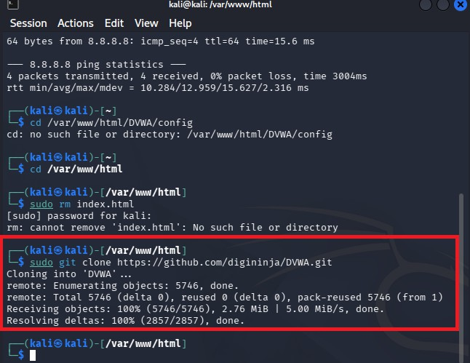
Download DVWA: sudo git clone https://github.com/digininja/DVWA.git

Step 9: Configure DVWA
Go to the configuration folder:

cd /var/www/html/DVWA/config Copy the sample configuration:
sudo cp config.inc.php.dist config.inc.php

Step 10: Create the Database

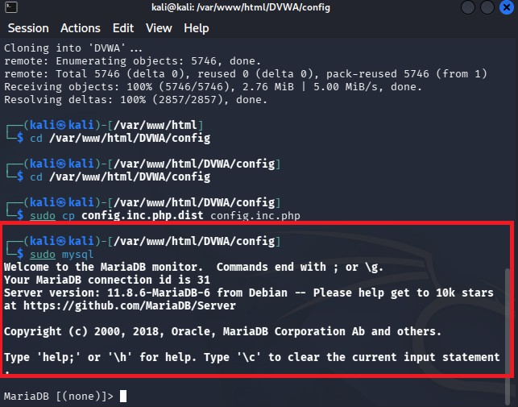
Open MariaDB: sudo mysql

Create the database:

CREATE DATABASE dvwa;

Create a user:

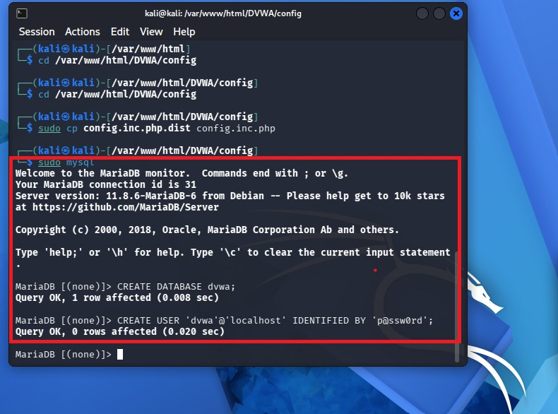
CREATE USER 'dvwa'@'localhost' IDENTIFIED BY 'p@ssw0rd';

Grant permissions:

GRANT ALL PRIVILEGES ON dvwa.* TO 'dvwa'@'localhost';

Reload privileges: FLUSH PRIVILEGES; Exit: EXIT;
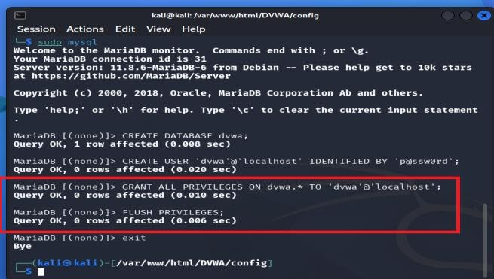

Step 11: Edit the Configuration File
Open:

sudo nano /var/www/html/DVWA/config/config.inc.php

Modify the database settings:

$_DVWA['db_server'] = '127.0.0.1';
$_DVWA['db_database'] = 'dvwa';
$_DVWA['db_user'] = 'dvwa';
$_DVWA['db_password'] = 'p@ssw0rd';

Save:

Ctrl + O Press Enter. Exit:
Ctrl + X

Step 12: Give Permissions
sudo chmod -R 777 /var/www/html/DVWA/hackable/uploads sudo chmod -R 777 /var/www/html/DVWA/config

Step 13: Restart Apache

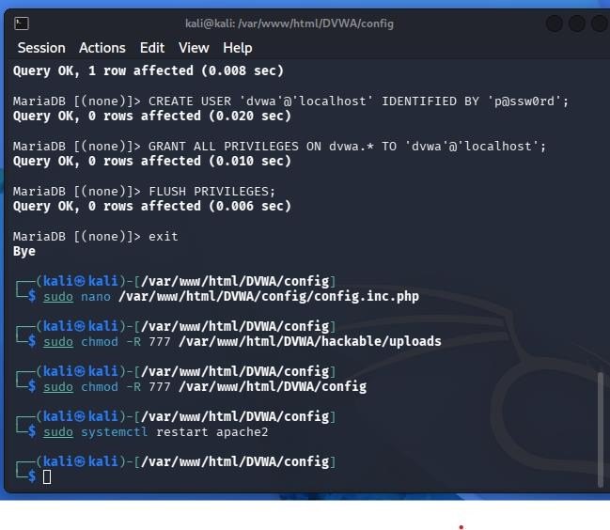
sudo systemctl restart apache2

Step 14: Open DVWA
Open Firefox.

Visit:

http://localhost/DVWA

The DVWA setup page appears. Click
Create / Reset Database

After the database is created, log in.

Step 15: Login
Username

admin

Password

password

Click Login.

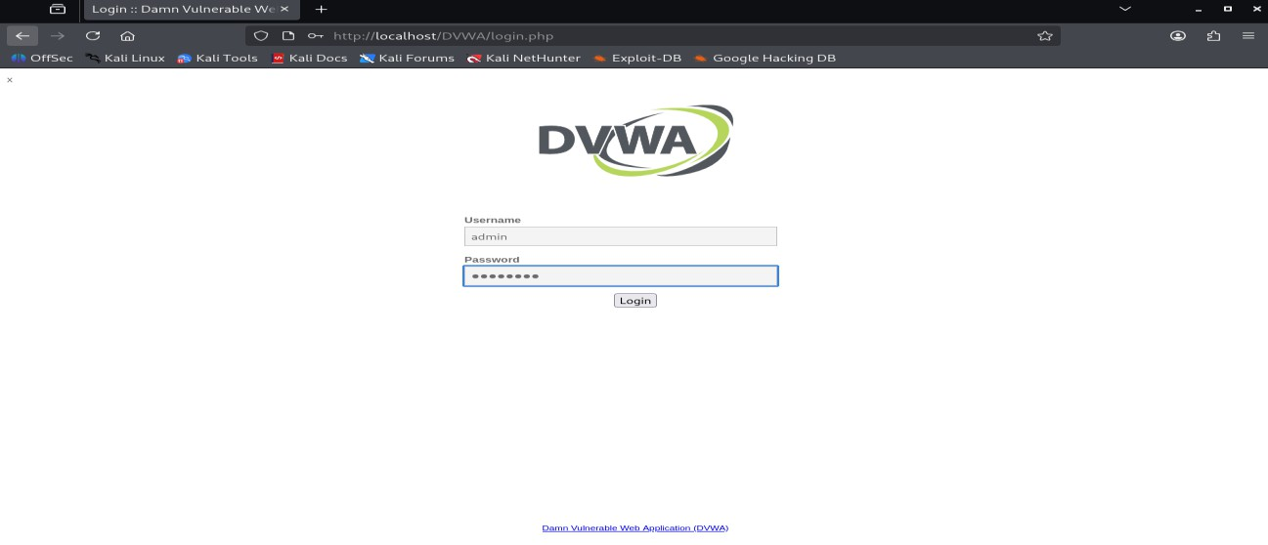

Step 16: Set Security Level
Click

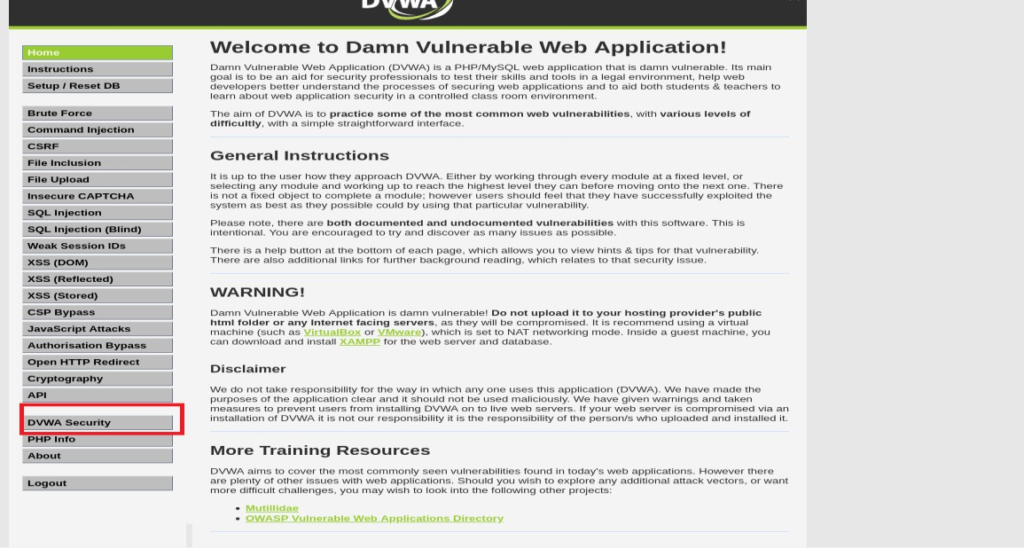
DVWA Security

Select Low

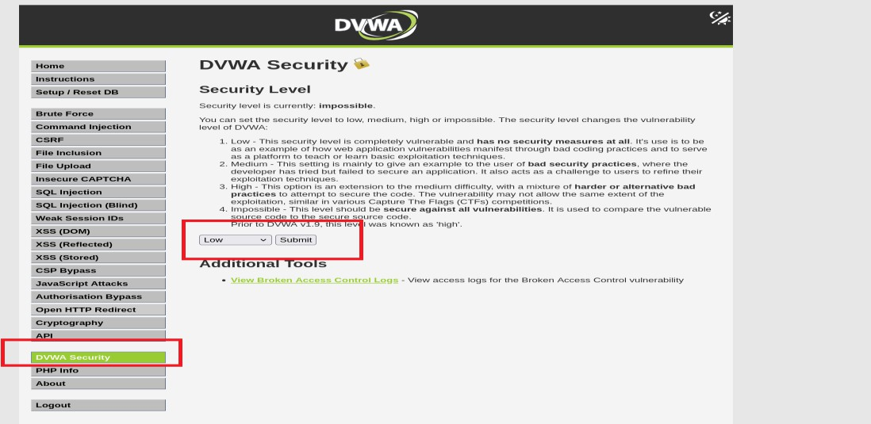

Click

Submit

Step 17: Open SQL Injection Module
From the left menu select

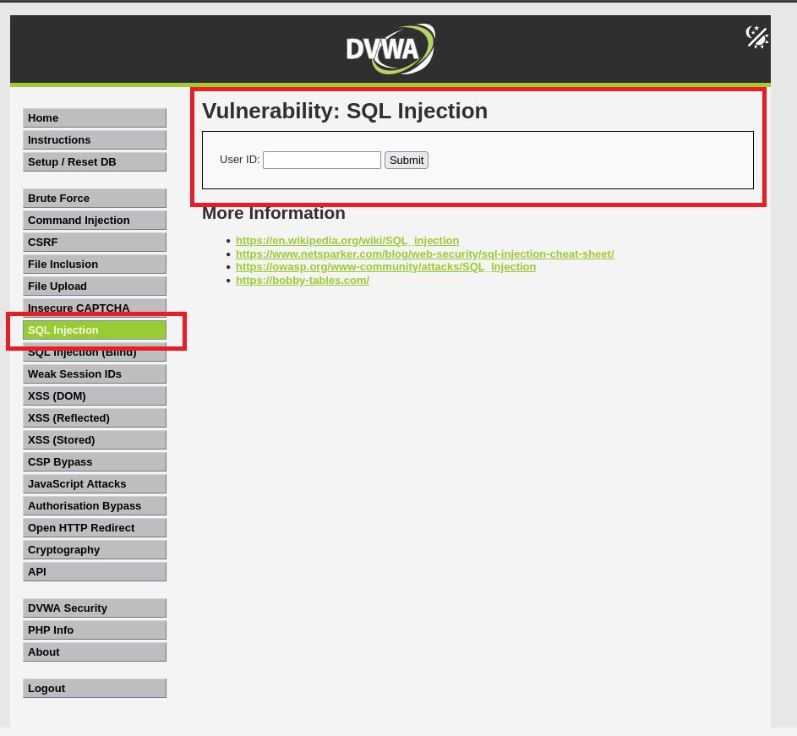
SQL Injection

You will see:

User ID:

[Submit]

Step 18: Test Normal Input
Enter

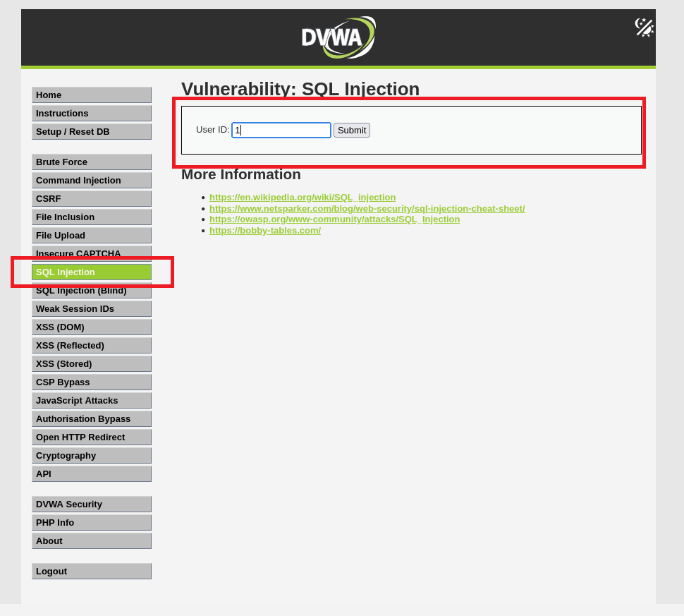
1

Click

Submit

The
page
displays
details
of
User
ID
1.

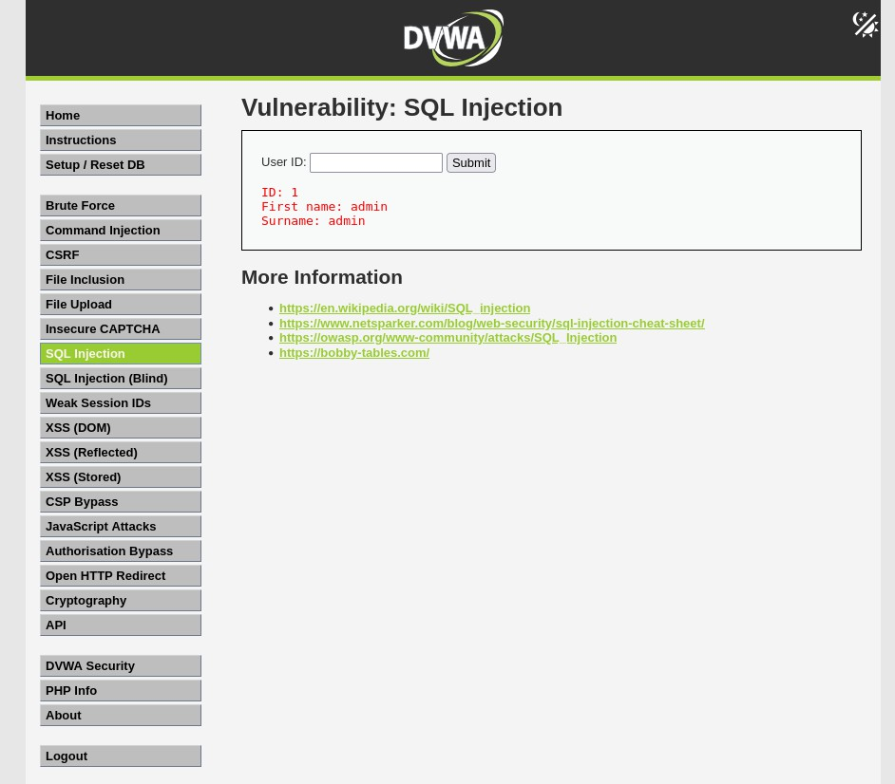
Step 19: Test for SQL Injection
Enter:

'

Click Submit.

If the application displays an SQL error or behaves unexpectedly, it suggests the input is not being handled safely. This demonstrates why applications should validate input and use parameterized queries.

Step 20: Observe the Results
Observe how different inputs affect the application's behavior. Record:
- Returned user information
- Error messages (if any)
- Differences between valid and invalid input

Step 21: Understand Prevention
Discuss the following secure coding practices:

- Prepared (parameterized) statements
- Input validation
- Least-privilege database accounts
- Hiding detailed database error messages
- Regular security testing

Shut Down Apache and MariaDB

- Open a terminal and run:
- sudo systemctl stop apache2
- sudo systemctl stop mariadb
- Verify they have stopped:
- sudo systemctl status apache2
- sudo systemctl status mariadb

Command Injection: To learn how command injection attacks work Tools: DVWA, Burp Suite, custom vulnerable web application.

Command Injection vulnerabilities occur when a web application executes system commands with un-sanitized user input. This lab will demonstrate how to exploit and understand these vulnerabilities using DVWA hosted on Metasploitable.
Metasploitable is a purposely vulnerable virtual machine created for cybersecurity training. It behaves like a real server but contains many known security weaknesses. Instead of attacking real systems, students practice on Metasploitable in a safe, isolated environment to learn how cyberattacks work and how to defend against them.

This experiment teaches students how a small coding mistake can allow a hacker to make a server perform unintended actions, and how secure coding practices prevent such attacks.

Objective
  - Understand how Command Injection vulnerabilities work.
  - Exploit the vulnerability to execute system commands.
  - Analyse risks and discuss mitigation strategies.
Step 1: Download Metasploitable2-Linux.zip.
Open a web browser on your Windows system.
Go to:

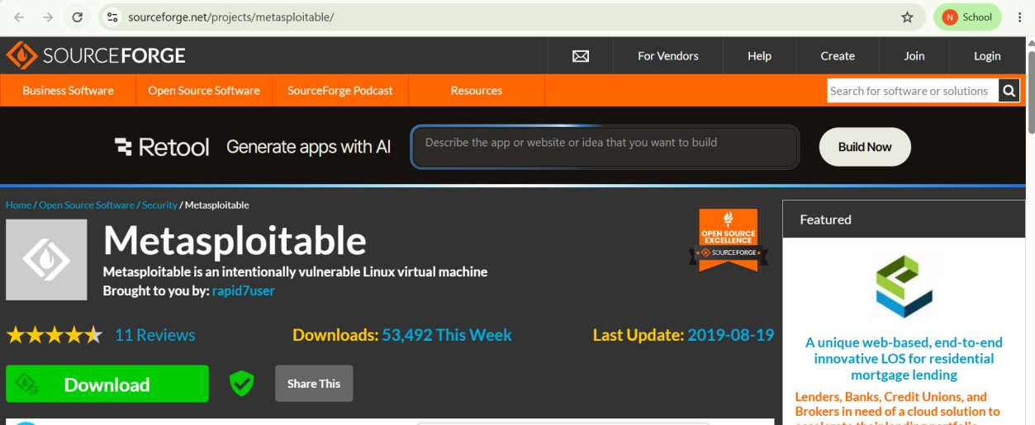
1. Go to: https://sourceforge.net/projects/metasploitable/

Step 2: Extract the ZIP File
After downloading:

- Right-click Metasploitable2-Linux.zip.
Select Extract All.
- After extraction, you should have a folder containing files such as:
- Metasploitable.vmdk Metasploitable.vmx

Steps to Import Metasploitable into Virtual box
In Virtual Box, click the new button at the top left.
A window titled Create Virtual Machine will appear. Fill in:
  - Name: Metasploitable
  - Folder: (leave the default)
  - ISO Image: Leave this field empty. (do not select anything)
  - Type: Linux
OS Distribution: Linux 2.6
  - Version: Ubuntu (32-bit) or Other Linux (32-bit)
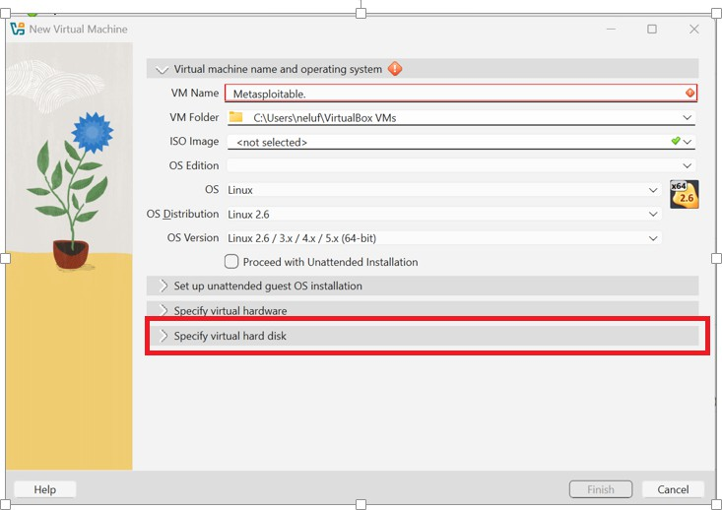

Next, expand Specify Virtual Hard Disk.
Click the small arrow next to Specify Virtual hard disk. You should see options like:

  - Create a Virtual hard disk now

  - Use an existing Virtual hard disk file
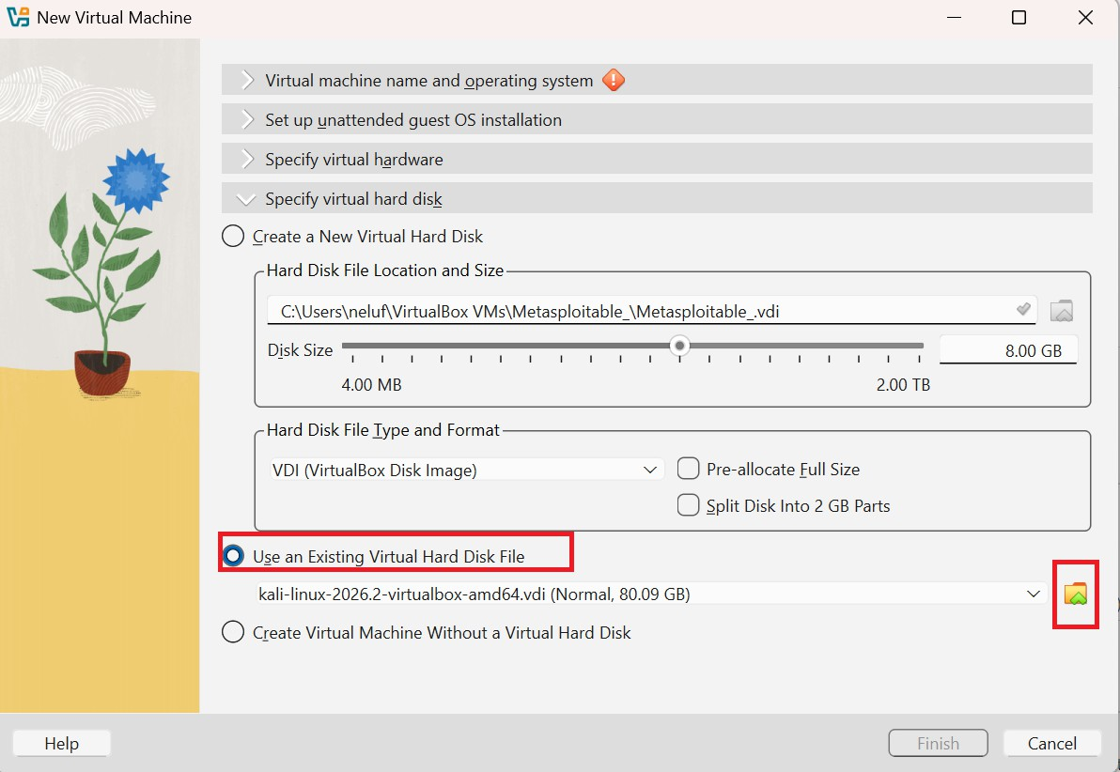

Choose Use an existing Virtual hard disk file, then browse and select:

Metasploitable.vmdk

(from the folder you extracted).

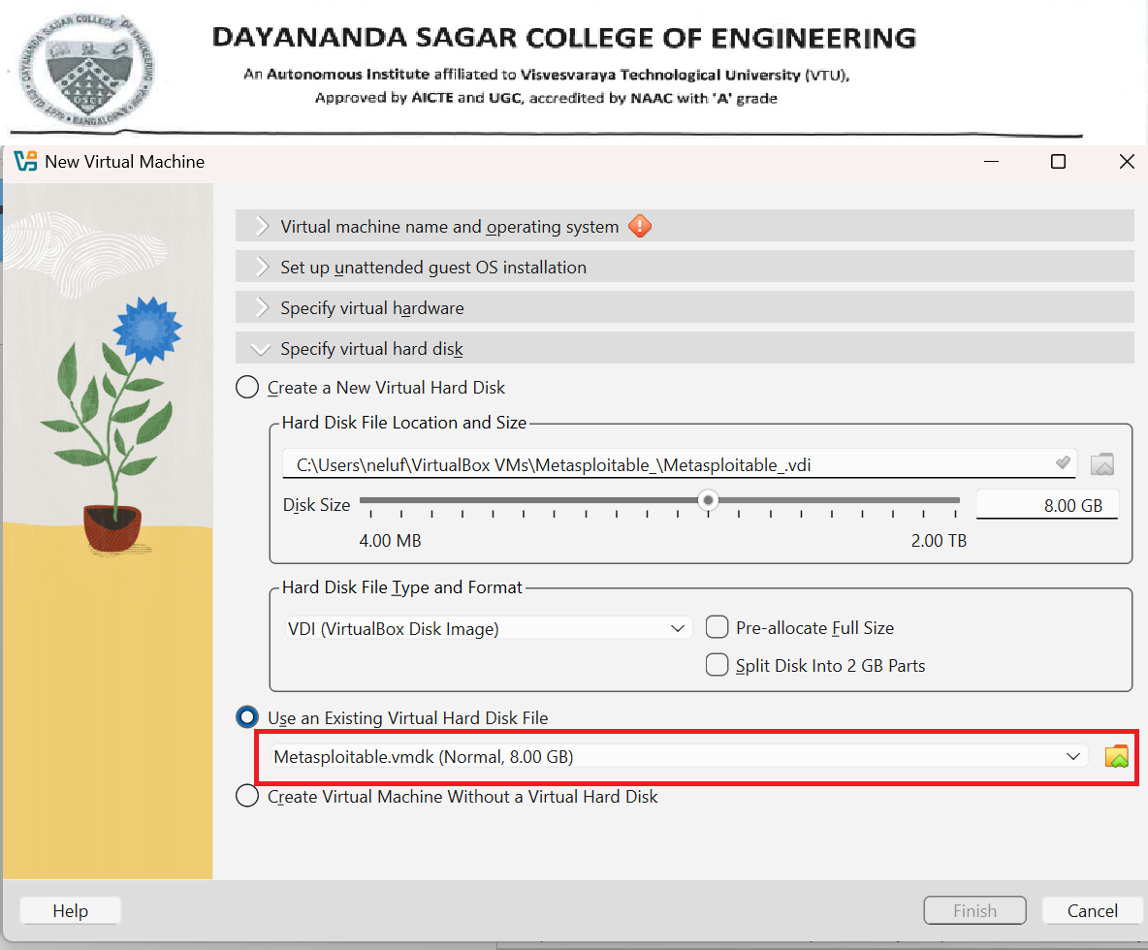
Click Finish.

You should now see Metasploitable listed on the left side of VirtualBox along with Kali.
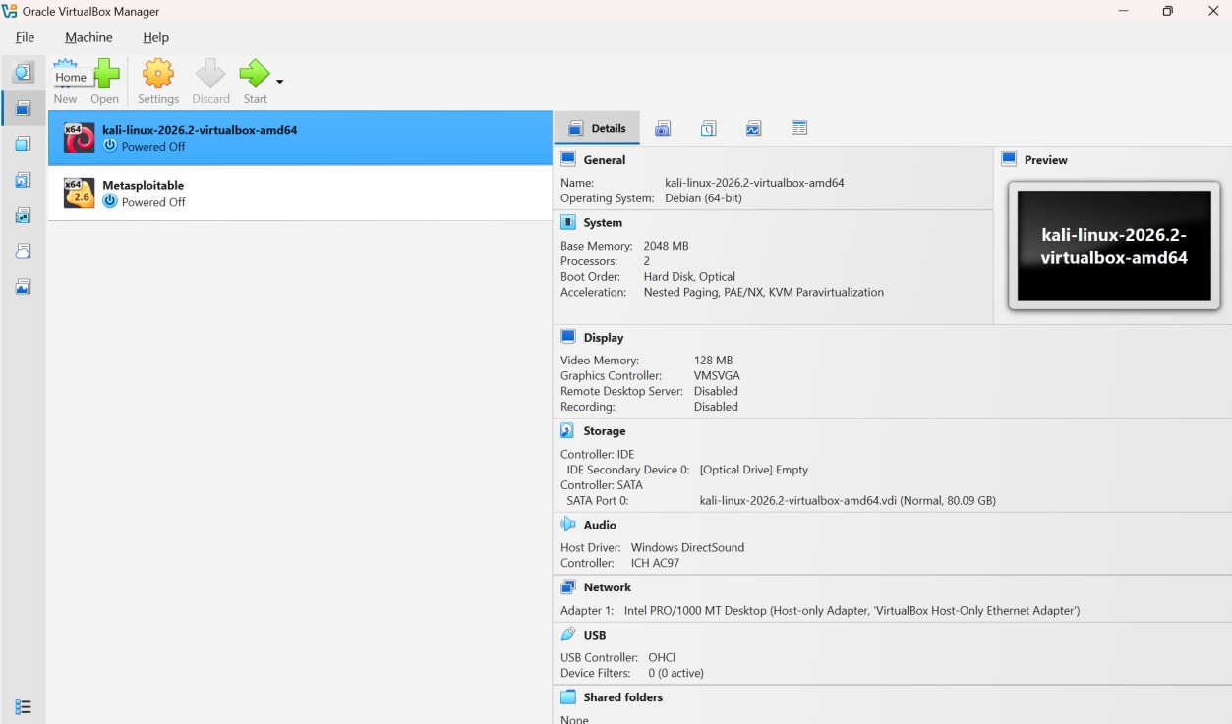

The next step is to configure the network so that Kali and Metasploitable can communicate. Step 1: Configure Metasploitable Network
- Select Metasploitable.
- Click Settings (gear icon).

Step 2: Go to Network

  - Click Network on the left.
  - Under Adapter 1, you'll see:

  - Attached to: Host-only Adapter

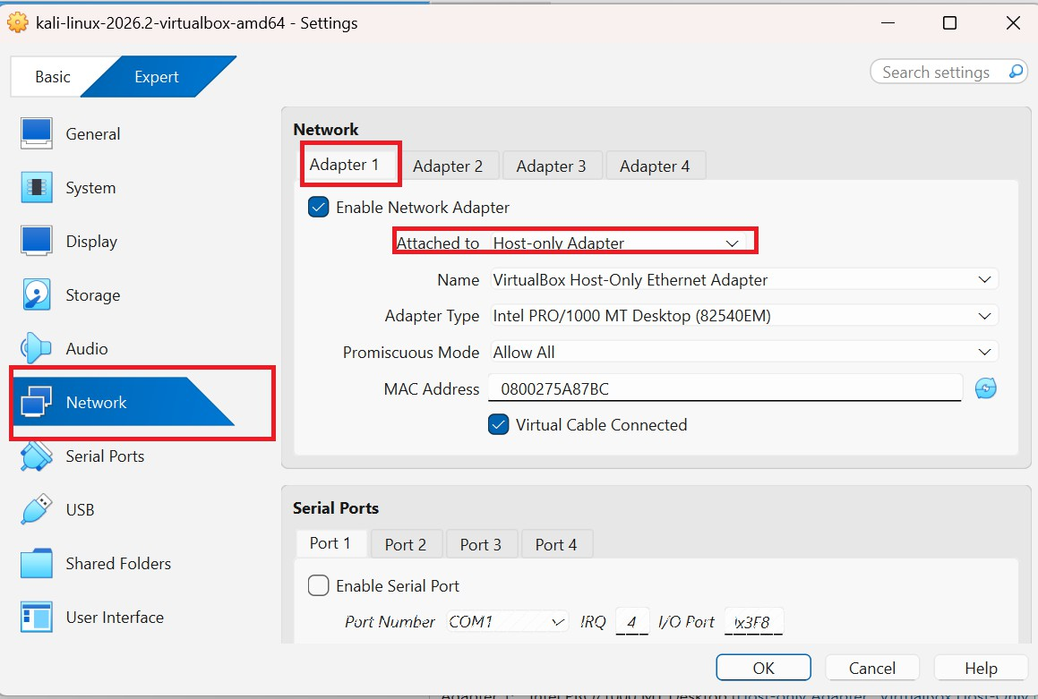

If you don't have a Host-only Adapter, choose Bridged Adapter for now (you can use the same adapter as Kali).

Step 3: Configure Kali the Same Way Select Kali Linux → Settings → Network.
Ensure Adapter 1 is set to the same network type as Metasploitable:

  - If Metasploitable uses Host-only Adapter, Kali should also use Host-only Adapter.

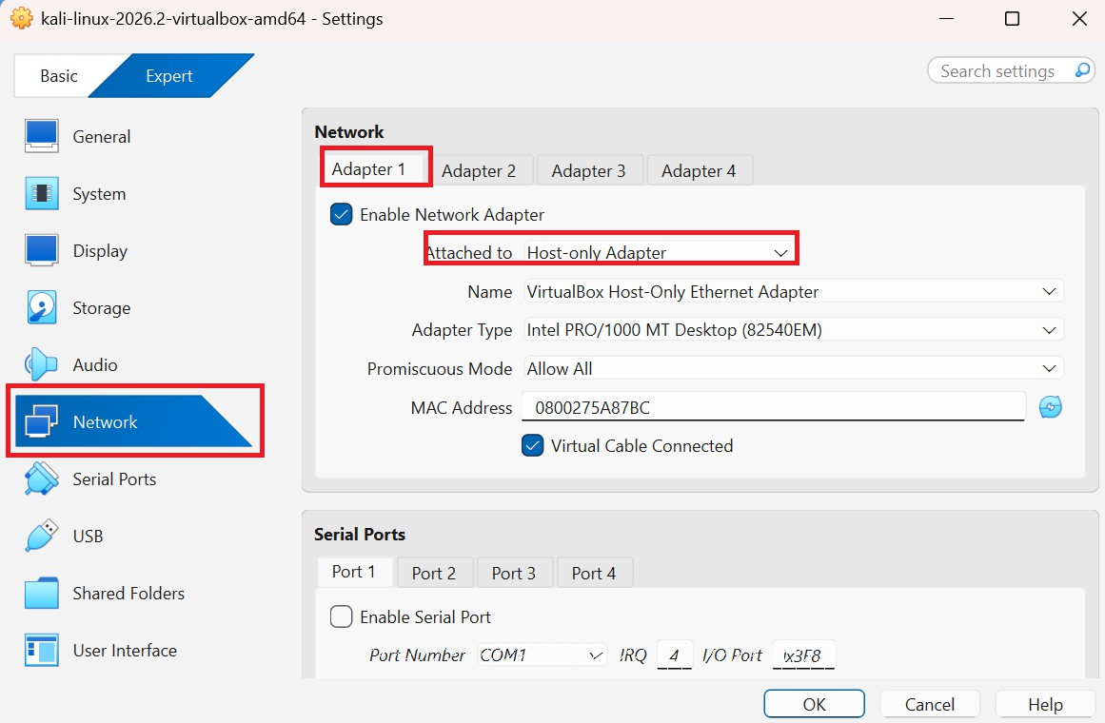
If Metasploitable uses Bridged Adapter, Kali should also use Bridged Adapter.
The network configuration is now complete. Now Start Both Virtual Machines
- Select Metasploitable → Click Start.

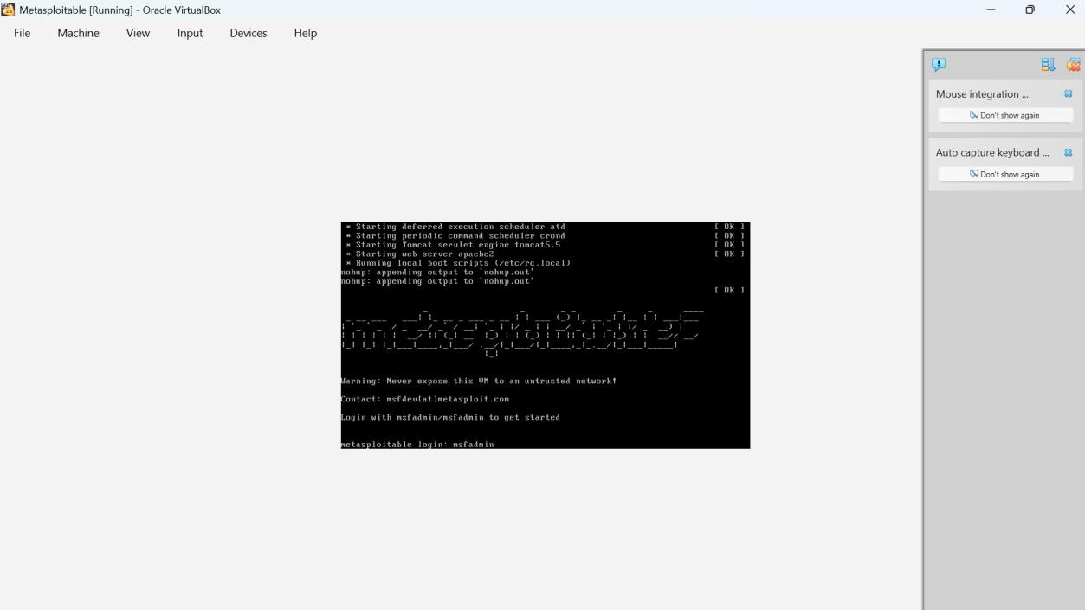
- Log in:

- Username: msfadmin
Password: msfadmin

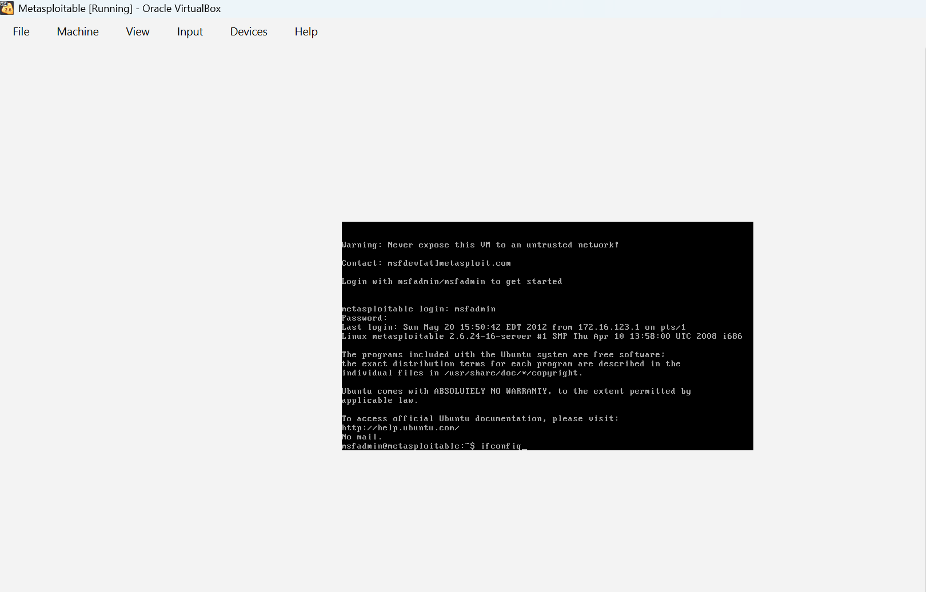
- After logging in, type: ifconfig

Look for the IP address under eth0, for example: 192.168.56.102 ((The IP address will vary depending on your machine.)
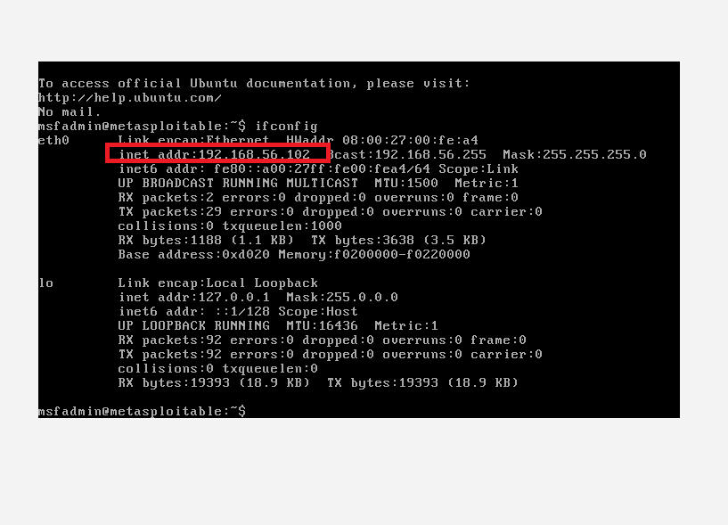
Note this IP address 192.168.56.102

Step 1: Start Kali Linux

Start your Kali Linux VM and log in.

Step 2: Test the Connection Open a terminal in Kali and type: ping 192.168.56.102

If
you
receive
replies,
the
connection
is
working.

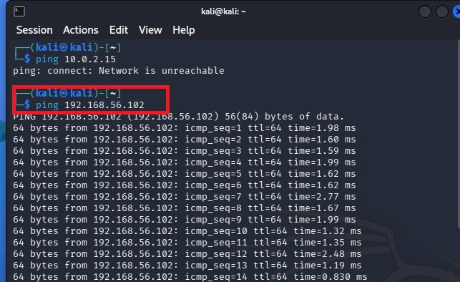
Step 3: Open DVWA Open Firefox in Kali.
In the address bar, enter:

http://192.168.56.102/dvwa

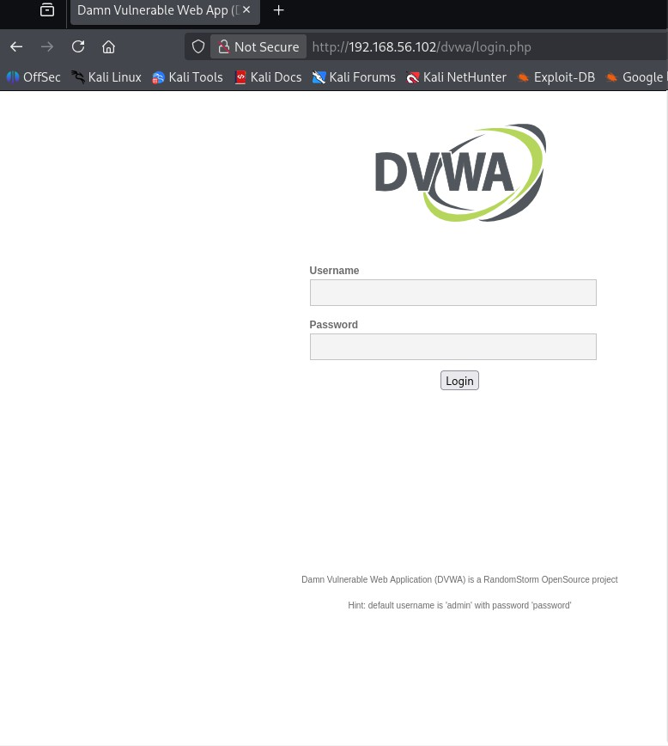

Step 4: Login to DVWA Use:
Username: admin
Password: password

If you see a Create/Reset Database button, click it first, then log in again.
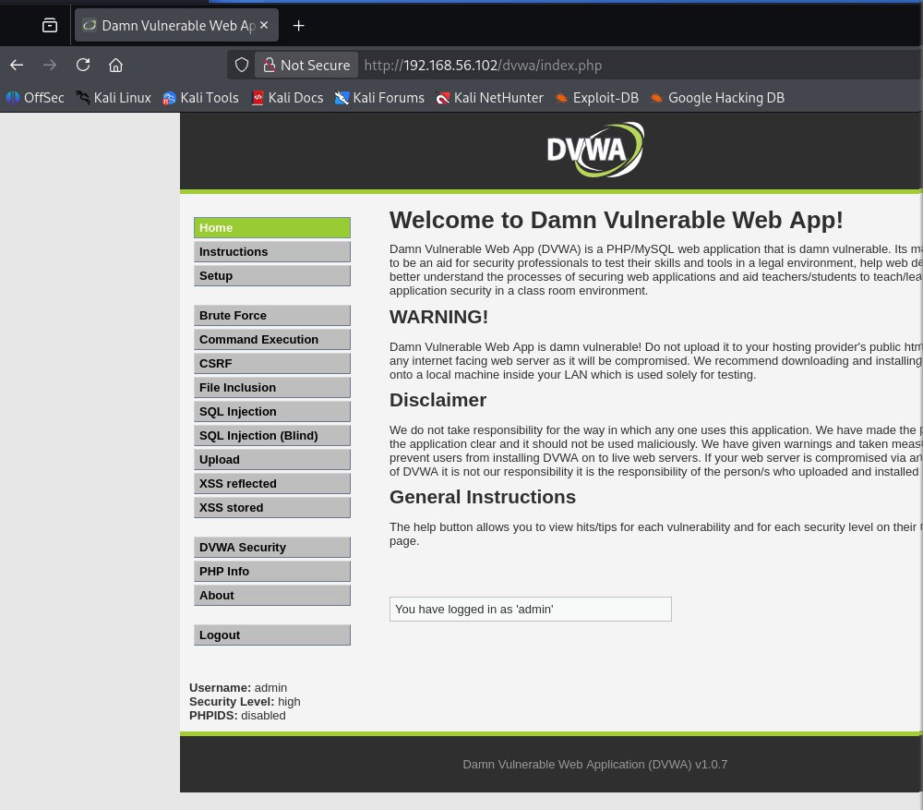
Step 5: Set Security to Low From the left menu:

DVWA Security → Select Low → Click Submit.
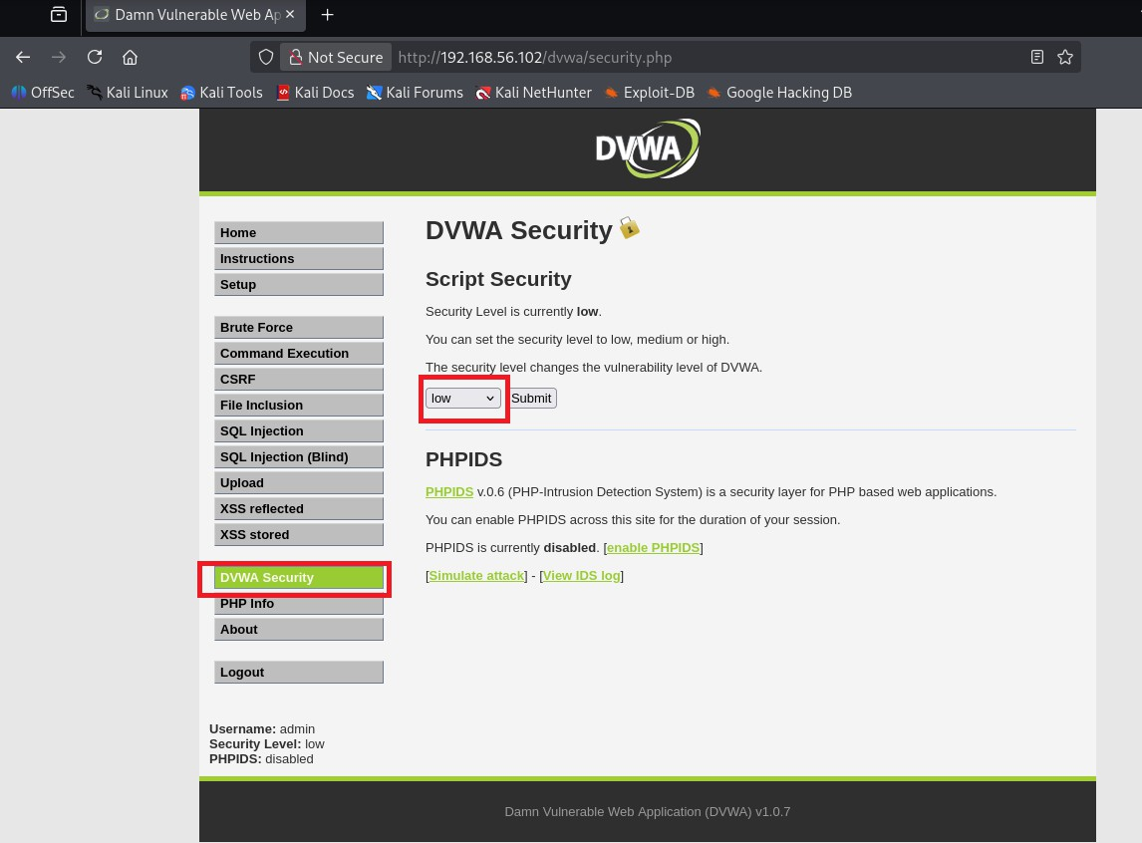

Step 6: Open Command Executio

Click Command Execution in the left menu. You'll see a text box asking for an IP address.

Step 7: Test the Application Enter: 127.0.0.1
Click Submit.

You should see the ping output.

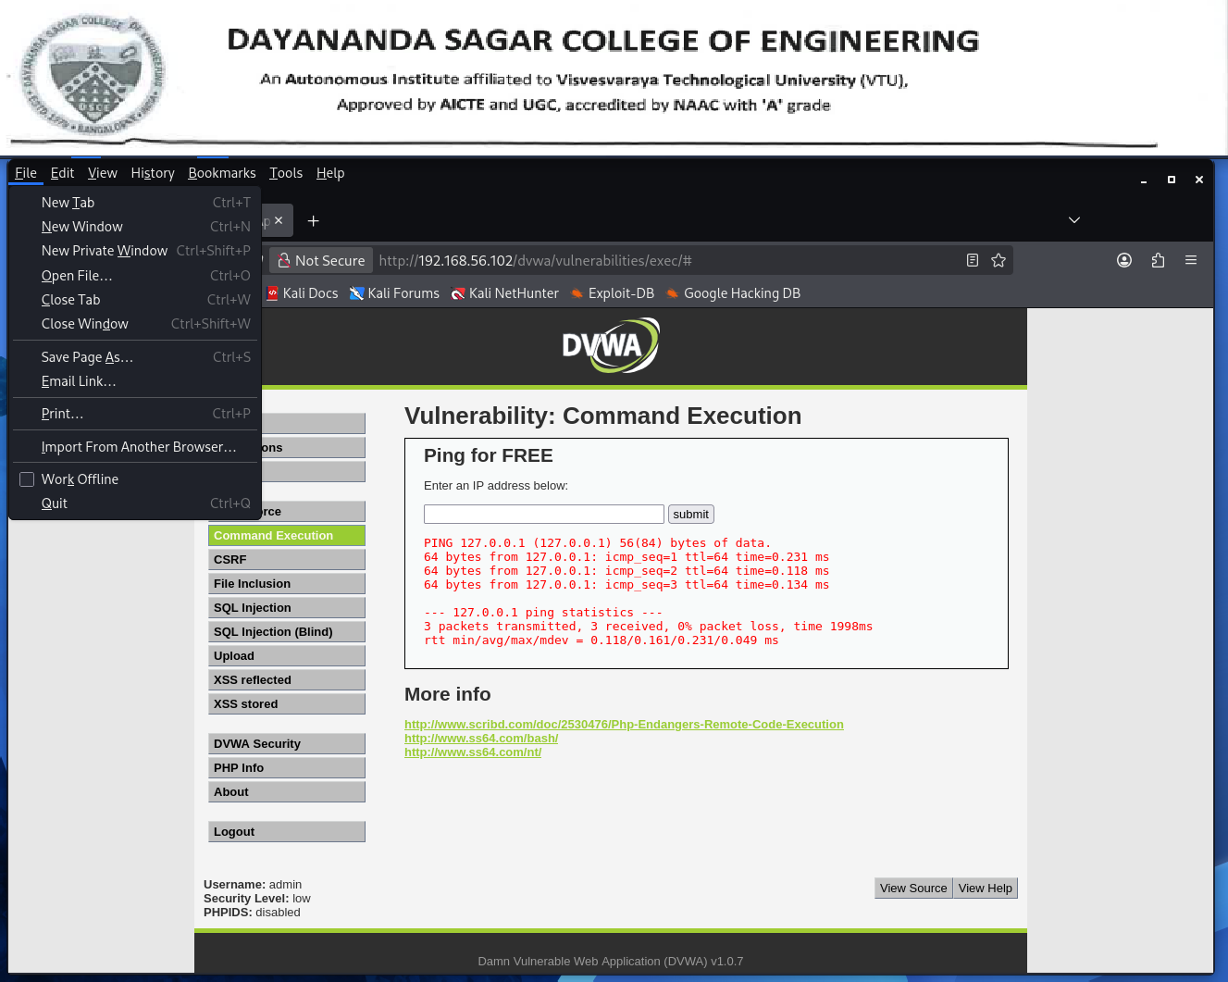

Step 8: Try Safe Command Execution Examples One at a time, enter:
127.0.0.1; ls

Click Submit.

Expected Output: A list of files and directories in the current folder.

Try the following commands:

127.0.0.1; pwd
output:

PING 127.0.0.1 (127.0.0.1) 56(84) bytes of data.
64 bytes from 127.0.0.1: icmp_seq=1 ttl=64 time=0.280 ms 64 bytes from 127.0.0.1: icmp_seq=2 ttl=64 time=0.298 ms 64 bytes from 127.0.0.1: icmp_seq=3 ttl=64 time=0.214 ms
--- 127.0.0.1 ping statistics ---
3 packets transmitted, 3 received, 0% packet loss, time 1999ms rtt min/avg/max/mdev = 0.214/0.264/0.298/0.036 ms
/var/www/dvwa/vulnerabilities/exec 127.0.0.1; whoami
127.0.0.1; ls -la

127.0.0.1; ifconfig

These demonstrate how the application executes additional commands because it doesn't properly validate user input.

Buffer Overflow Illustration using GCC
GCC (GNU Compiler Collection) is a free and open-source compiler used to convert source code written in programming languages such as C, C++, Java, and Fortran into executable machine code that a computer can run.

This experiment demonstrates the concept of a buffer overflow, one of the most common software security vulnerabilities, in a controlled laboratory environment. Students learn how exceeding the allocated memory for user input can cause a program to crash or behave unexpectedly, emphasizing the importance of secure coding and proper input validation. A real-world example is a login or banking application where improper handling of user input could lead to application failure or unauthorized access. This experiment helps students understand secure programming practices, memory management, and the importance of developing reliable and secure software systems.

Step 1: Open the Linux Terminal
Start your Linux virtual machine (Kali Linux or Ubuntu). Open Terminal.

Step 2: Create the C Program
Create a new file named buffer.c.

nano buffer.c

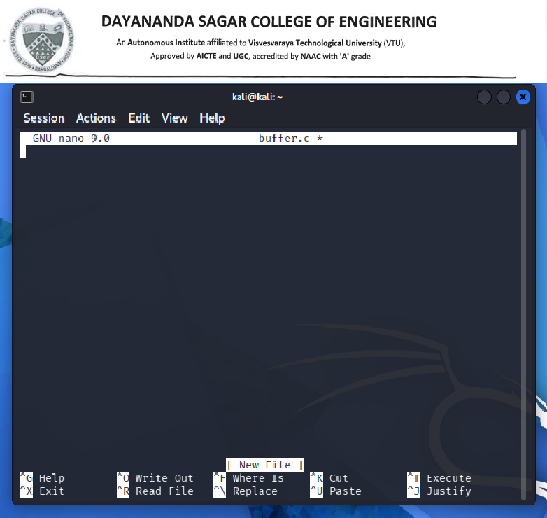

#include <stdio.h> #include <string.h>

int main()
{
char buff[15]; int pass = 0;
printf("\nEnter the password:\n"); fgets(buff, sizeof(buff), stdin);
buff[strcspn(buff, "\n")] = '\0'; // Remove newline

if(strcmp(buff, "thegeekstuff"))
{
printf("\nWrong Password\n");
}
else
{
printf("\nCorrect Password\n"); pass = 1;
}

if(pass)

{
printf("\nRoot privileges given to the user\n");
}

return 0;

}
Save the file. Press
Ctrl + O

Press Enter

Then

Ctrl + X

Step 3: Compile the Program
Compile using GCC.

gcc -g -fno-stack-protector -z execstack -o buffer buffer.c

Explanation

- -g → Includes debugging symbols.
- -fno-stack-protector → Disables stack protection.
- -z execstack → Makes stack executable (used only for demonstration).

Step 4: Run the Program
./buffer

Run 1 (Correct Password)
Enter

Thegeekstuff
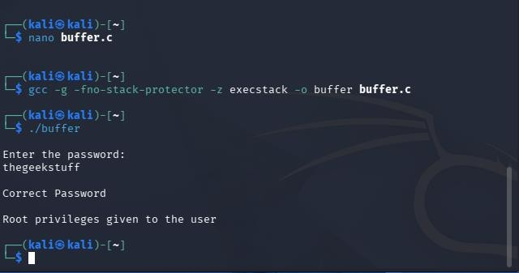

Output

Enter the password:

thegeekstuff Correct Password
Root privileges given to the user

Run 2 (Incorrect Password)
Run again.

./buffer

Enter

hello

Output

Wrong Password

No root privileges are granted.

Run 3 (Attempt Buffer Overflow)
Run again.

./buffer

Enter a long string, for example

Hhhhhhhhhhhhhhhhhhhhhhhhhhhhhhhh
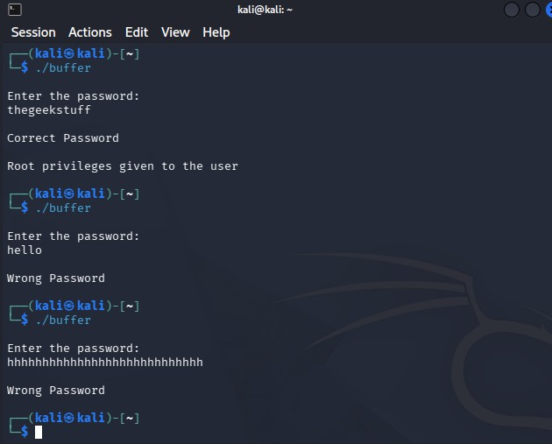

Depending on your compiler and system, one of the following may happen:

- Program crashes (Segmentation Fault)
- Unexpected output
- Variable values change

Program behaves abnormally

Explore Compare It Tool to Compare of two files for Forensic Investigation
This experiment introduces students to the Compare It! tool, which is commonly used in digital forensic investigations to compare two versions of a file and identify any differences between them. The tool displays both files side by side and highlights added, deleted, or modified content, making it easy to determine what changes have been made.

During the experiment, students create two text files with slight differences and use the Compare It! tool to analyze them. The software automatically highlights modifications using different colors, allowing students to quickly identify altered information. Students also learn how to navigate through the differences, synchronize changes if required, and generate a comparison report for documentation.

, forensic analysts compare files recovered from a suspect's computer with the original files to determine whether evidence has been altered. This experiment helps students understand the role of file comparison tools in digital forensics, evidence verification, and incident investigation.

Software Required
- Windows Operating System
- Notepad
- Compare It! Tool

Step 1: Create the First Text File
  - Open Notepad.
  - Type the following content:

Student Name: Rahul USN: 1DS22CS001
Department: CSE Semester: 7 College: DSCE

  - Click File → Save As.
  - Save the file as:

File1.txt

Choose an easy location such as the Desktop.

Step 2: Create the Second Text File
- Open Notepad again.
- Type slightly different content.

Example:

Student Name: Rahul Kumar USN: 1DS22CS001
Department: Computer Science Semester: 7
College: DSCE Bangalore

- Save the file as:

File2.txt

Store it in the same folder as File1.txt.

Step 3: Install Compare It!
- Download the Compare It! software from the official website. https://www.grigsoft.com/wincmp3.htm
- Run the installer.
- Follow the installation wizard.
- Click Finish after installation.

Step 4: Launch the Compare It! Tool
- Open Compare It! from the Start Menu or Desktop shortcut.

The application window opens with two file selection panels.
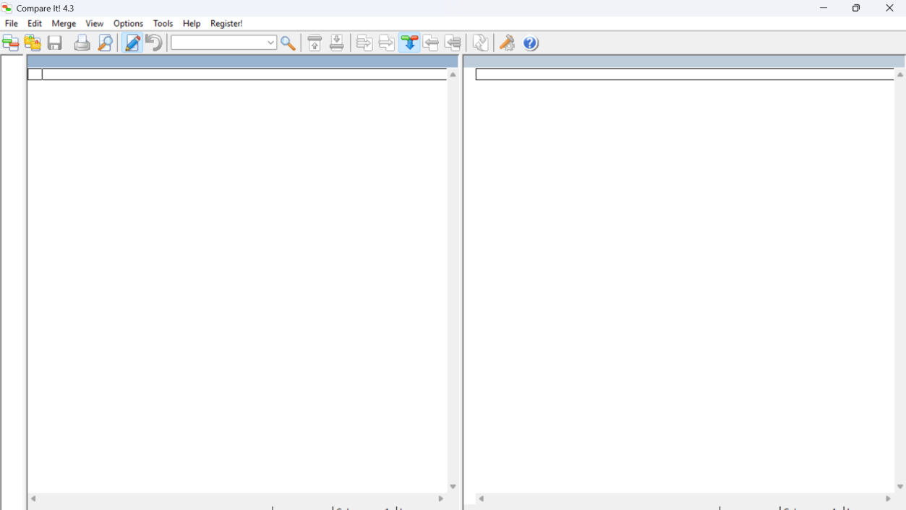

Step 5: Load the First File
- Click the Browse/Open button on the left side.
- Navigate to the location where File1.txt is saved.
- Select File1.txt.
- Click Open.

Step 6: Load the Second File
- Click the Browse/Open button on the right side.
- Select File2.txt.
- Click Open.

Step 7: Compare the Files
- The software automatically compares both files.
- Both files are displayed side by side.

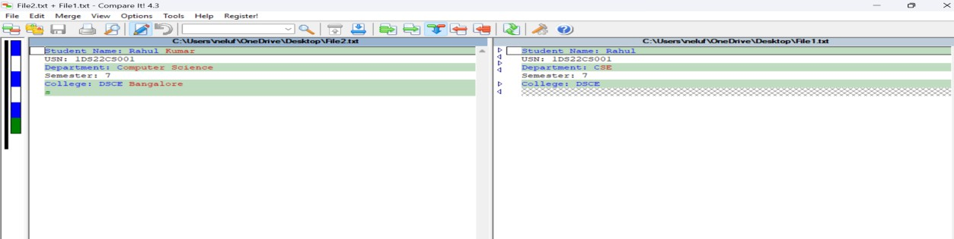
- The tool highlights differences using different colors.

Typical color indications include:

  - Yellow – Modified text
  - Green – Newly added text
  - Red – Deleted text (The exact colors may vary depending on the software theme and settings.)

Step 8: Analyze the Differences
Observe the highlighted differences, such as:

  - Changed student name
  - Modified department name
  - Additional words added to the college name

These highlighted changes help investigators determine what information has been modified.

Step 9: Navigate Between Differences
Use the toolbar buttons or keyboard shortcuts to:

  - Move to the next difference
  - Move to the previous difference

This allows easy examination of every change between the two files.

Step 10: Synchronize or Copy Changes (Optional)
If required:

- Select a highlighted difference.
- Click the Copy Left → Right or Copy Right → Left button.
- The selected change is copied to the other file.

This feature is useful for synchronizing file contents.

Step 11: Generate a Difference Report

- Click File → Print or Print Preview.
- The software generates a report showing all detected differences.
- 3.Save or print the report for documentation.
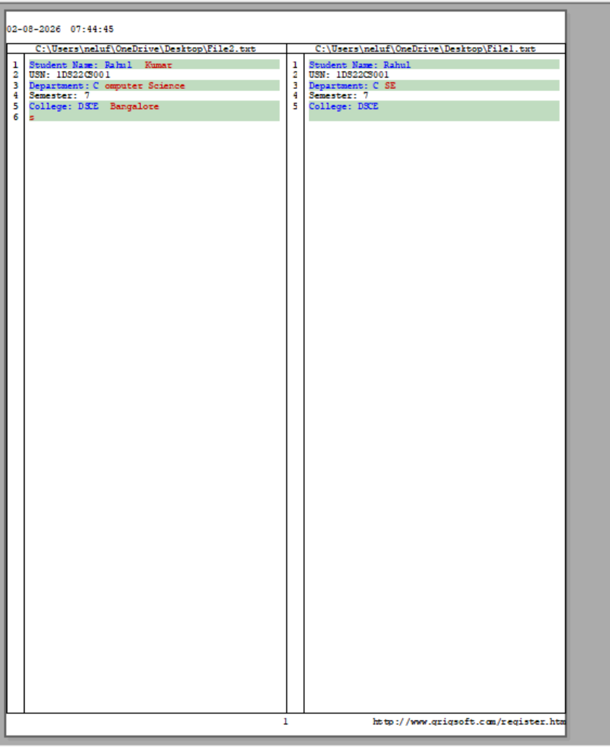

The report can serve as evidence during forensic investigations by recording the differences between the two files.

Step 12: Close the Application
- Review the comparison results.
- Save any required reports.
- Close the Compare It! application.

